Radio Transport Security

Technical Solution Description

Version 2.1

**Table of Content**

1. Executive Summary 4

1.1 Fast and easy network rollout with vendor certificates 4

1.2 Low OPEX through secure automated procedures 5

1.3 Investment protection by securing legacy Equipment 6

1.4 Conclusion 8

1.5 Conclusions and recommendations by 3GPP 8

2. Technical Solution Overview 9

2.1 Impact of Security to Radio Access Transport 9

2.1.1 Deploying the Security Solution 10

2.1.2 LTE Radio Transport Security 11

2.1.3 3G Radio and Transport Security 13

2.1.4 OAM Traffic in the Radio Transport Network 18

2.1.5 Conclusions about Transport Security 22

3. Deployment of the Security Gateway 24

3.1.1 IPsec-GW at the aggregation point between MHB and Core network 24

3.1.2 IPsec GW placed in front of the Packet core network 27

3.1.3 IPsec-GW Redundancy 28

3.1.4 Tunnel Deployment Options 30

3.2 Deployment of the PKI 33

4. NSN Secure Identity Delivery Process (SID) 34

4.1 Initial Registrations of BS to the Network 36

4.1.1 Registration for BS Nodes with Vendor Certificates 36

4.1.2 Registration for Legacy Nodes without Vendor Certificates 38

4.1.3 NSN certificate deployment service 39

4.1.4 Manual and alternative certificate registration methods 40

5. Security Gateway Platforms 43

5.1 Juniper SRX 43

5.2 Cisco WSG 44

5.3 Performance limitations of the IPsec-GW 45

6. Public Key Infrastructure Platform 47

6.1 PKI Hardware Platform 47

6.2 Scalable Software Architecture 48

6.2.1 Policy based processing 49

6.2.2 Rapid setup and easy maintenance 49

6.3 High Availability 50

6.4 PKI Networking Setup 51

6.4.1 CA traffic trunk 52

6.5 Hardware Security Module 53

6.5.1 Accessing CA keys 54

6.5.2 Need for HSM 55

6.6 PKI Use cases 55

6.6.1 Vendor CRL 56

6.6.2 Automated Certificate Revocation 56

6.6.3 Automated Certificate Renewal 56

7. Management System Integration 57

**Glossary** 59

# Executive Summary

In the following document, we describe a Radio Access Transport Security Solution with Reference to 3GPP LTE Network Domain Security and the corresponding Authentication Framework as TS 33.210 and TS 33.310. This solution comprises: Security Gateways (IPsec-GW) on the MBH-network Edge as well as a Certificate Authority (a.k.a. PKI) for certificate enrolment and certificate lifecycle management of the IPsec-GW and eNB identities, based on X.509v3 public key certificates.

New 4th Generation LTE networks are designed as flat-hierarchy and all-IP architectures, and as such always prone to various security threats raised from the IP world. This fact has been widely discussed and is recognized also by 3GPP (see for example 3GPP TR33.821 “*Rationale on Security Decisions for LTE*”). However, the spreading of IP throughout all sectors and mobile technologies – such as with Abis or Iu over IP interfaces – widens both, the attack surface for general IP security threats as well as the need and applicability of a transport security solution. Once a security Gateway is installed for one mobile network technology, it can also offer protection for traffic from other technology nodes. Legacy- and new mobile network technologies – 3G WCDMA, I-HSPA and LTE – can be integrated into the NSN Radio Access Transport Security.

It is further a fact that security constraints do often stand in contrast to unproblematic deployment and operation of networks. Many security solutions tend to make the network more complicated and more expensive, at the same time not showing a clear return of this investment.

Nokia Siemens Networks has turned this problem issue into an opportunity for operators and developed an approach, where all security precautions of BS rollout can be applied automatically and with an absolute minimum of interaction or additional steps to be performed. In fact, applying a security solution as proposed will increase the operational profits, because security is not “added on top” of the regular network. Instead, NSN’s 4th generation Base Station (BS) systems are designed and produced in the factories with “built-in” security to optimize and support rollout procedures. Older technology can be taken along into the scope of the new security solution so that IP focused modernizations in the access network will not again raise the question for additional security.

Following paragraphs describe the main value proposals that NSN offers with its NSN Radio Access Transport Security.

## Fast and easy network rollout with vendor certificates

New Base-Station types like the NSN LTE eNB or I-HSPA BTS are designed for SON/PnP setup. During this process, a BS automatically discovers transport network and radio parameters, then downloads it and activates the configuration. This allows much faster and smoother rollout of the network, but due to the usage of IP technologies it also opens an easy entrance for attackers and rogue devices into the same:

Because modern 4G base stations are often deployed in easily accessible, public locations without particular physical security, further use regular RJ45 connectors and Ethernet interfaces. To protect Core and OAM networks, it must be ensured, that only genuine vendor base stations can connect to the Mobile Backhaul (MBH). Connection of any other devices – that could easily plug in to the Ethernet jack on a BS site for “malicious PnP – must be prevented. Regular Firewall filters do not provide sufficient protection in this case, because they lack the functionality to reliably “recognize” (authenticate) their peer devices.

Security-Gateways extend the pure “*stateful-inspection*” function of firewalls not only by adding confidentiality and integrity protection to the traffic stream. They also provide the ability to authenticate peer nodes and only allow connection of authorized devices. Due to the high number of eNBs, central administration of the authentication and identity data is a major challenge in such IPsec deployment.

NSN offers a PKI solution for that purpose, which has been tested for interworking with both, different BS types and Security Gateways. BS and IPsec-GW authenticate each other by means of X.509v3 public key certificates. Such a certificate authentication comprises 2 parts: A secret private key that the eNB must generate during its SON/PnP initialization, and a corresponding public key which will be certified in the PKI as an electronic, inseparable ID of the BS. In combination, no node that is not a genuine NSN (or other recognized vendor) BS will be able to connect to the network. It will not be able to obtain (enroll) a certificate and can hence not connect to the IPsec-GW. But once the 4G BS has “enrolled” its electronic ID (certificate), it will pass the IPsec-GW, complete the SON/PnP setup and automatically contact NetAct. From there it receives e.g. its LTE radio configuration and immediately starts functioning as e.g. LTE eNB.

This procedure has valuable advantages for the deployment of each single site:

* Compliance with 3GPP recommendations 33.210 and 33.310
* No need to share security relevant information with field installation staff
* No need to rely on much more complicated and error prone L2 security configuration
* No need to manually apply any configuration during 4G BS commissioning
* Fully secured setup, no possibility to connect other nodes than genuine eNB
* Minimized need to train field engineering staff, only mechanical/voltage installation to be checked

In result, the NSN security solution guarantees a fully secure, fully automated fast deployment. Thus, ensuring rollout schedules and CAPEX budgets to be met.

## Low OPEX through secure automated procedures

Main reason for using a PKI is not only to allow an automated lifecycle management of BS certificates. Much more, it is needed to maintain a centralized repository of BS identities and access data. During the lifetime of the BS, the certificates are not only used to authenticate the BS to the IPsec-GW. They are also used – for example – to authenticate TLS (Transport Layer) connections towards the Network Management Applications. Certificates are a universal identity of the BS for network operation. They can be revoked or renewed at one central location. A PKI turns into a central “identity management system” for network elements that allows in a secure manner, to execute many mass operations for which the lifecycle of the BS certificate and the lifecycle of the BS itself are connected. Such mass operations are, for example:

* Users on the BS need to be maintained when people change roles in the company
* Authentication for mass operations like Radio-network plan downloads, alarm synchronization, …
* Secure inventory checks/synchronizations to verify deployed hardware/serial numbers in the field
* Mass-reconfigurations in disaster cases like earthquakes (connect BS to different IPsec-GW)

All those examples have in common, that a programmed mass operation towards many BS needs to be executed. In traditional 2/3G networks, such procedures are carried out from an OSS and normally provide only very limited security because e.g. all BS share the same Access-password (in order not to have to manage 100s of passwords). Often, scripts are used where such passwords have to be stored in clear text or where decryption methods are unveiled that disclose the passwords to anyone who can read the script code or monitor its execution.

A PKI facilitates the access control and at the same time increases security in the radio access network. Though it does not replace user-accounts in BS, it enables secure device-identities and is prerequisite for a centralized user account management of NEs. Thereby, the operational cost of the network is decreased by having one central instance – the PKI – on which identities can be verified “online/real time” and be used along programmed actions. Changes of identity data to one or many BS becomes easy, because the PKI allows for central access to it and renewal of authentication data can be done without sharing access secrets to human operators (since private keys are stored automatically and securely inside the BS only and hence no unrecognized tampering or secret issuing of false certificates is possible.)

## Investment protection by securing legacy Equipment

In LTE, the „flat hierarchy“ networks do not have any TelCo protocol terminations in the aggregation layer, S1 interfaces directly connect from the eNB towards MME for signalling or SAE-GW on the user plane. Legacy networks like 3G do still offer a layer of protection before core network elements can be reached

* In traditional 3G networks, encryption is done between the Radio Network Controller (RNC) and the User Equipment (UE), not having (most) data as unencrypted clear text in the BS.
* Further, traditional networks do usually deploy base stations inside shelter cabinets, making unauthorized physical access somewhat more problematic.

Nevertheless, as technology inside and outside the mobile networks advances and sees modernizations, those traditional protections lose effect for various reasons.

Only the high number of physical cabinets makes it difficult to monitor if physical access to a BS is legitimate or not. In a network with a total of 15k base stations only, if each cabinet is opened less than once a year, a „cabinet door open” warning would pop from somewhere at least 1/hour in a central management system. More frequent maintenance or higher number of BS cabinets will directly multiply the appearance of that warning, so that it is often not tracked down or at least unauthorized opening of a cabinet would not be easy to discover fast.

Besides the raising difficulty in managing the increasing number of BS, other factors significantly start penetrating the security level of networks:

* Better and more widely available hardware and software on the free market compromise the traditional security. Along with an increasingly visible weakness of 2G and 3G encryption algorithms, wide availability of cheap, small „home base stations“ and open Source decryption software allow active and passive tapping of calls between any termination points, on the air interface as well as inside the wired network. The needed knowledge is easily available to anyone and has lead in the later past to several breeches that found echo in media and journalism.
* Staff outsourcing, managed services approaches and churn-over of people and tasks have lead to a significant diffusion of access networks with different OAM personnel. In result, the amount of security relevant information that has been irreversibly exchanged became significant as well and it is difficult for operators, to track who can access what at which (or both) sides of a firewall! This can best be encountered by replacing old-fashioned physical and password-based access as far as possible, and migrate to modern protection methods that do not require to share secrets with human operators.

When converging legacy sites to new access technologies such as *pseudowire* technology or pure IP based networks, NSN transport security allows to take the modernisations like packet Abis or Abis/Iu-over-IP directly along. In the course of actions taken during a backhaul modernisation, 2G and 3G BS can as well be equipped with a similar X.509 certificate based authentication logic and continue functioning under the shelter of IPsec towards a centralized security gateway. Thus offering contemporary protection and replacing physical protection by network layer security.

## Conclusion

Following Chapters of this document will give technical reasoning that a new technology – IP network layer and commodity physical interfaces and topologies – can’t be brought into the network without bringing along the needed security technology! If it comes to deployment scenarios for 3G BS that create similar setups as LTE, then also similar security scenarios must be considered!

But IPsec is not “*the price for using IP*” much more it is an additional benefit! Because in connection with a PKI, IPsec modernizes security procedures and eases handling of sensitive information to the same extend as IP transport modernizes the payload part!

Usage of IPsec with certificate authentication is the state-of-the-art security technology. It protects investments into new and legacy technology, reducing the management effort and keeping „the human factor“ out of the security equation as far as possible. Thus ensuring minimum OPEX for risk management and protecting both, old and new investments.

## Conclusions and recommendations by 3GPP

It is in the interest of most of NSNs customers, to deploy new technologies according to and in line with 3GPP standards and recommendations. While standard compliance does indirectly guarantee interoperability and investment protection, it first of all and directly ensures that defined quality standards can be met!

In regards to the solution described in this document, we refer to the following 3GPP documents and sections that underline, how the described solution directly improves network quality in terms of 3GPP definitions:

* *3GPP TS 33.401 (Security Architecture), chapter 5.3.2:*

*“Security associations are required between the EPS core and the eNB and between adjacent eNBs, connected via X2. These security association establishments shall be mutually authenticated and used for communication between the entities.”* Hereby 3GPP directly defines, that compliance with its security Architecture cannot be achieved e.g. by planting a Firewall in front of the EPC Perimeter. Much more, it is needed (in the further course of the document) that all eNB connections are full IPsec connections.

* *3GPP TS 33.821 (Rationale of Security Decisions in RAN), chapter 5.2 & 5.3*

A wide variety of threats rising from unsecured S1 connections is described directly in Chapters 5.2 and 5.3 of this rationale, and indirectly with other threats mentioned in the same document. The described solution mitigates those threats directly and is therefore necessary to be considered along any LTE solution or transport network modernization that is supposed to be SAE capable.

# Technical Solution Overview

## Impact of Security to Radio Access Transport

Our Radio Access Transport Security Solution is mainly designed to mitigate one particular type of scenario: That an attacker could plug in a stealth device between BS and the upstream network! This allows acting like a (false) BS and gives access to all traffic of that base station in upstream and downstream direction. The term “plug in” allows several interpretations, ranging from plugging in an RJ45 Ethernet jack to a BS mounted on an inside-wall to tapping on an unencrypted MWR link between a BS and the network. On a pure networking perspective, Transport Security has mainly the following purpose:

* Protect the upstream network nodes so that malicious traffic can’t get into the Converged Core. Scope of this protection is not only DoS, but protection from any Man-in-the-Middle attacks. Covering manipulations or eavesdropping of traffic on User- , Control- and Management Plane.
* Protect downstream traffic of user connections from Man-in-the-Middle attacks.

Depending on the mobile network and transport technology in place, above threats bear different risk levels. For LTE and I-HSPA with flat all-IP architecture, omitting of a Transport Security Solution can easily have fatal consequences. In 2G networks, the solution does not eliminate the threat of a compromise on the air interface, but improves at least upstream protection of the network. To analyze the impact of having (or not having) a transport security solution, below score card roughly summarizes the native threat-level in different technologies. Mind, that “native” means there is no IP Security Solution deployed (yet)!



**Figure 1:** Scorecard for general threat-level towards different Radio Technologies and without a Radio Transport Security Solution being brought into place.

### Deploying the Security Solution

To protect both, the upstream core- and OSS/BSS network as well as subscribers in the downstream direction, a security gateway (IPsec-GW) is placed on the edge towards the Radio Transport. All connections towards the Core network (or: towards Radio Controllers in 2G/3G) shall then pass the Sec-GW[1], which has the following functions:

* Authenticate all Base Stations nodes or other IP endpoints that want to pass the network border in an upstream direction or establish “sideward” connection e.g. BS-to-BS. Either all BS have to authenticate towards each other for meshed connectivity[2], or a hub-and-spoke topology with the IPsec-GW as central hub is built! No traffic of unauthenticated nodes should be allowed anywhere in the network.
* State full inspection (i.e. Firewall filtering) of traffic between the core/OSS network and authenticated Base Stations, and between Base Stations.
* Provide confidentiality and integrity protection (i.e. encryption) of the traffic between Base Stations and IPsec-GW.

Mind, that we are “*talking general*” and above three security claims are not valid for only one or some access technology! The Radio Transport Security Solution offers the above protection for all BS types that are capable of using IP towards the aggregation layer!



**Figure 2:** Radio Access Transport Security and targets of the mitigated threat scenario.

NSN offers a variety of BS types with different connectivity features for HW (i.e. interfaces) and SW (i.e. protocol support). All BTS models based on Flexi architecture are HW-ready for IPsec and firewall capabilities. SW availability is defined in the NSN NWS roadmaps. Depending on Radio Access Technology and BTS generation, IPsec capability comes either with the Transport Sub-Module or with the System Module. This allows any recent BS model to connect to the backhaul transport using IP, generally without requiring additional hardware.

With the described security functions enabled, many attack scenarios are mitigated to a considerable extent and comparing the scorecard at the end of the chapter (see ) with that in shows significant improvement after deployment of the Radio Access Transport Security Solution.

### LTE Radio Transport Security

In LTE, 3GPP has left a wide space for TelCo operators to decide on security and did not draw too narrow lines. As the following Chapters on 2G and 3G security history will show, you “can barely do something right” when trying to mitigate the security situation for 20 years in the future with what is known and common today!



**Figure 3:** S1-MME and S1-U Communication in LTE without Transport Security Solution.

Since all network layer functions upstream the air interface are based on IP, it was a natural decision to define LTE’s “Network Domain Security” framework by pointing to the IPsec RFCs from IETF and define an IPsec Gateway to be placed on the border between Converged Core Network and IP Radio Transport (see ). In Section 3 of this document, different positions for the IPsec Gateway within the all-IP transport architecture are discussed.

LTE offers integrity protection and encryption on the NAS Signaling protocol, but no protection at all for e.g. User traffic, S1AP protocol or the complete MME IP protocol layer. In total, LTE access security passes several straits requiring particular attention: Using simple “COTS” hardware with RJ45 Ethernet jacks, unencrypted and unauthenticated IP connections between eNB and the core network elements as well as increasing deployment of LTE eNB in publicly accessible locations are particular problems to be encountered. Those problems are not completely LTE specific, but still LTE is more vulnerable due to its flat network hierarchy. For example, in 3G an encryption of user traffic between RNC and UE protects against a sort of Man-in-the-Middle attacks that are easily mounted in LTE.



**Figure 4:** S1-MME and S1-U Communication in LTE with Transport Security Solution. The Protection layer encapsulates all traffic above IP between eNB <> IPsec-GW.

As described in the executive summary of this document, NSN Radio Transport Security addresses those problems, and satisfies requirements of the 3GPP Network Domain security as well as the Authentication Framework. If this solution is not deployed, the userplane and IP access will remain unprotected! Above shows a simplified illustration of the LTE protocol stacks along the network, and how the Transport Security solution mitigates the connectivity risks.

### 3G Radio and Transport Security

Similar as in 2G, also 3G security relies on physical access control and protection of the underlying network by means of cryptography. The principle of physical protection might be discussed in general and applies for 3G with similar arguments as for 2G or LTE. But still, the implications are different and the risk level in 3G is generally lower.

* Encryption starts already in the RNC and is terminated in the UE. Hence it passes through the NodeB and through the Radio Access Transport with an encrypted connection. This is mainly important to MWR links, but also relieves from the dogma of requiring a “totally sheltered” BS.
* Cryptography has been improved and properly published. Not only stronger and better reviewed Algorithms are used, but also stronger mechanisms (i.e. better signaling procedures) are applied for authentication, privacy and integrity protection.

So far breaking of 3G cryptography has been demonstrated only on academic level and is far less common thanin 2G.

#### Physical Protection

If a mobile network nowadays is considered “large”, one might calculate around 20-30 Mio subscribers and 15k-20k BS. If each BS would be “physically touched” once every year only, then a “cabinet door open” or similar warning that indicates this physical interference would pop up in a central OMC approximately every 25-35 minutes. Once the condition is cleared, the OMC alarm would normally disappear. This does not include more frequent maintenance of only some nodes, or cabinet doors that have been forgotten and accidently left open. It seems therefore at least dubious, if physical protection as a retro-active method can efficiently protect the network. One could also claim, that in order to remain undiscovered, it is more decent to break-open a cabinet door rather than trying sophisticated actions that raise more attention.

Networks have reached sizes in which we find physical security alone is neither an adequate nor a feasible protection. In the OMC, noise is defined by Alarm events and not by the physical sound of a breaking lock! And we don’t count on the neighbors when making a risk analysis … Besides that, physical security clearly contradicts an important aspect of operator business models: Fast and easy deployment of small energy-footprint and low-weight BS.

#### Protection offered for 3G by Radio Transport Security

Since 3G attack patterns are basically identical to 2G, the difference between both technologies remains only in the transport network. While all user traffic and *most* signaling are protected between RNC and UE, mainly the Iub interface between the NodeBs and RNC can be subject to attacks that would be mitigated by a Radio Transport Security solution! Mind also, that “most” signaling is protected, but not all.

* The Control Plane in Iub is based on NBAP (NodeB Application Protocol), specified in 3GPP TS 25.433 – a 1200 pages opus. NBAP control traffic is not protected.
* RRC traffic between RNC and UE is mostly protected, but several messages that need to be exchanged before AKA is completed – plus some others for efficiency reasons – are not encrypted and can be used to mount DoS attacks[3].
* User plane traffic is authenticated, integrity protected and encrypted on WCDMA system level. However, some underlying Iub and Uu protocols are not- or not fully protected and tampering on lower layers is possible! For example, manipulations on the Frame Protocol FP can influence power control information.

Any of the above bullets describe unprotected messaging that could become subject to an attack. So far, this could be used only to demonstrate DoS attacks of different scale. This imposes a relevant risk to secure operation of the 3G network, even if breakings of the cryptographic protection are only “academic” and of very little practical use.



**Figure 5:** DoS attack on the Iub is possible due to unprotected NBAP and RRC messaging. IP commodity HW and accessible Iub cabling enforce mitigation.

In the risk management equations, DoS plays an important role. In the scales as described, it can be used to quickly disrupt (i.e. switch off) service for selected or all users in an RNC area. Besides revenue loss, a repeated attack might cause legal problems as well since the network has to provide emergency-call capabilities and guarantee availability. On top, DoS from an Iub cable over an area of several NodeB is can be an easy support to mount attacks on the air interface: If 3G service is disrupted, all subscribers will go to 2G mode and become vulnerable for the attacks described before for 2G.

With a Radio Transport Security Solution, those threats are mitigated. A Security Gateway at the Aggregation Layer (e.g. in RNC sites or even included in RNC site router solutions) will effectively protect all IuB messages plus user traffic.

#### 3G evolution into I-HSPA

WCDMA technology is evolved in the existing frequency ranges towards an entire scale of products that smoothly allow an evolution or transition of the existing 3G networks. New concepts and products are spawning Femto-cells with home base stations, bundling of carries in different ways (HSPA) up to a revised 3G network architecture as in I-HSPA. While LTE introduces new network elements and protocols, I-HSPA is an evolution of the standard 3G network and completely reuses existing core network and radio interface.

In a first phase of I-HSPA, the main idea is to move packet-switched HSPA functions from the RNC to an I-HSPA Adapter inside the NodeB. In a later Phase the same should be done with circuit-switched non-HSPA functions: A NodeB becomes I-HSPA enabled by adding a specific Transport Sub-Module. It implements an adapter (ADA) that fulfills the offloaded RNC functions. In result, all 3G HSPA packet-network functions will be decentralized and RNC capacity at the aggregation layer is only needed for CS-voice. The network becomes “flatter” with I-HSPA, and the Iur interface between NodeB’s or between NodeB and RNC becomes an optional component.



**Figure 6:** Comparing different transport paths and network layers in R99 WCDMA (upper) and I-HSPA (lower). Optional “pure I-HSPA” (no RNC) is shown.

The optional “Direct Tunnel” feature that has already been available in HSPA and a pure PS deployment as shown in the above figure create a scenario that looks very similar to LTE, but using upgraded and new 3G WCDMA base stations instead of eNB. However, the setup voids a major advantage that classic 3G had: It turns the – at least mostly – encrypted and protected Iu interface into an unencrypted and mostly virtual interface inside the NodeB. In I-HSPA, the Gn interface between GGSN and NodeB is not protected. This applies also for the Iups case, if the Direct-Tunnel feature would not be used and UP traffic go via the SGSN as it does in regular R99. A difference between 2G GSM and R99 on the other hand is that also data traffic is encrypted only in the RNC and not like in 2G already in the SGSN. Signaling connections face the same issue and are unprotected. That means: From the ADA inside the I-HSPA NodeB upwards, all I-HSPA connections are unencrypted. This creates another similarity from I-HSPA to LTE: It needs to be operated with Radio Transport Security in place (i.e. IPsec Gateway on the aggregation layer).

#### Evolution towards Femto Scenarios

From a pure marketing perspective, it makes sense for operators to think about flexible extensions of their mobile service into “family homes” by offering so-called Home-NodeB (in 3G femto) or Home-eNB (for LTE). Capacity on the air interface is not shared among too many subscribers, but only in a “clearly arranged” user group, which makes planning easier. Truly converged operators do anyway own access lines into building infrastructures (like DSL or TV cable). It is a next step in developing their growths, to offer a variety of innovative home-services that can be combined with mobility features. Besides such motivation, there is also a clear connection between coverage and revenue per subscriber. When using Femto, cells become smaller and coverage inside the existing frequencies is extended. A similar effect is gained by WiFi scenarios, when unlicensed frequencies can be used to extend coverage, or when both scenarios are combined.



**Figure 7:** Brief and exemplary outline of a Femto (or WiFi) scenario. Centralized controllers offer access to the mobile core’s services from a home-device.

For regular mobile network base stations, we have not any more accepted the argument that they are locked *securely* inside physical shelters. It is clear, that for scenarios where cabling ends in a user’s basement at least similar concerns are valid. Current “fixed internet access” scenarios have similar issues and those are solved mainly by the use of physical media and the nature of the connection: There is only the user’s own connection on “his” H-NodeB, hence not much surprise to be expected. Authentication on the other hand easily becomes an issue on a different layer. Depending on the business model, an Increasing amount of heterogeneous devices – phones, gaming consoles, all kinds of HW or SW players – will be required to authenticate against a network, and to do it without having an own USIM. With a centralized PKI, those services could be controlled on different layers, e.g. by having H-NodeB refusing connections from devices that do not present a proper certificate, which they must enroll against payment from a provisioning system.

Various scenarios are possible here, and standardization as well as product- and service development are ongoing. The Femto/WiFi scenarios are mentioned here to emphasize, that all future models of authentication and network security will rely to a large extend on the same objects that are used in the Radio Transport Solution: IPsec gateways and centrally managed X.509 certificates for authenticating IPsec peers.

### OAM Traffic in the Radio Transport Network

Long before discussing Radio Transport Network Convergence, and long before voice traffic and signaling went over IP, OAM traffic has already used IP transport inside its isolated “DCN”. Even most seasoned MSCs and STPs have meanwhile replaced their OSI Q.3 interface by IP or at least OSI-over-IP connections and finally eliminated the need for CLNS networking over LAN everywhere! Besides some in-band management[4], most of today’s OAM traffic is *over IP* and at least all traffic that reaches the OSS reaches it over IP.



**Figure 8:** OAM traffic secured by TLS between management application and BS.

Independent from security in the access or transport networks, OAM traffic has developed an own approach to security which is based on TLS. OAM traffic is normally proprietary information, sent sometimes over standardized protocols like HTTP, but also often sent inside proprietary interfaces like NSN’s CORBA-based NWI3. Using TLS for authenticating peer applications and nodes has been good practice for a while already, and profits today from utilizing a centralized PKI. In contemporary NSN networks, BS and Radio Controllers comprise the mass of managed elements. The X.509v3 certificates they use for TLS connectivity towards OSS are the *same* certificates that we use towards the IPsec-GW. There is only one identity for each BS or RNC, and it is manifested with one identity-certificate for both, IPsec and TLS.



**Figure 9:** OAM traffic secured by TLS between management application and BS plus IPsec protection for all TLS and non-TLS traffic on the network layer.

Both services, TLS and IPsec offer mutual peer device authentication, integrity protection and confidentiality (i.e. encryption) along the transport path. As above figure illustrates, TLS and IPsec are not redundant options or would even contradict each other! Much more, an IPsec tunnel ensures that all OAM data is really sent via an encrypted and authenticated connection. Mind, that around 65% of the rules for the NetAct firewall are made for unsecured, unencrypted protocols!

From OSS point of view, IPsec identities depend on trust into an external device – the IPsec-GW which verifies the certificate of the BS. This is actually a drawback compared to TLS, where identities are verified directly by the OSS applications itself. But in turn, the IPsec tunnel protects information also from management applications which do not use TLS, such as SNMP or other connectionless bits[5] that might bypass the secure transport layer of TLS.

In most networks, a Firewall is placed in front of the OSS as so-called DCN-Firewall, in NSN NetAct this is normally a Juniper SRX240 cluster. If the network is small (<5000 BS) or if no other traffic besides OAM should be inside transport protection, it makes sense to consider termination of OAM IPsec in the DCN Firewalls. It brings the termination point closer to the actual application endpoint, which extends protection. Further, it is easier to manage since then all IPsec connections would be terminated inside one central IPsec-GW rather than having several decentralized IPsec-GWs in the aggregation layer. However, there are a few thoughts to spend on this idea:

* Aggregation happens on BSC/RNC sites that can also provide IPsec capability in existing devices. For example, Cisco 7600 series as one of the NSN recommended site-router solutions for L-SMAS can be equipped with SAMI blades (at the cost of interface capacity) and thereby gain IPsec capabilities. Hence, even without dedicated IPsec Gateways, it is a possible and more scalable approach to terminate IPsec in the lower layers of the aggregation and transport network.
* Even small networks with few thousand nodes will bring the IPsec capabilities of an SRX240 branch gateway to its limit: Per datasheet capacity, it can handle around 1000 concurrent IPsec tunnels. For networks that require around 5000 tunnels, already a larger SRX3400 series will be required.
* Same as all traffic from different planes and technologies, also OAM transport should be considered along a central and holistic strategy rather than planning each segment on its own. This ensures better performance and investment protection.

OAM traffic can be secured using any of the above described and different IPsec deployment scenarios – or even entirely without IPsec using only TLS. However, the recommendation is, to not handle OAM traffic alone as a separate issue. Since protection of all S1 connections by IPsec is required according to 3GPP, at latest for LTE networks the most scalable and probably most cost efficient approach is to protect management traffic along with signaling- and user plane traffic with decentralized IPsec-GWs in the aggregation layer, as it is described by this solution document.

In each case – regardless of the position of the IPsec-GW or even in a pure TLS scenario – a Public Key Infrastructure (PKI) is used to manage peer identities.

#### Human Factor in Network Operation

On previous pages this document already acknowledged our doctrine, that stateful inspection (i.e. FW) alone can’t provide sufficient protection of the core and OSS/BSS network. Besides that this advise is strictly in line with 3GPP, another reason to it is the way how Radio Access Networks are built and rolled out. One more related reason is the way how OSS applications are used. Both reasons in sum could be called “human factor” and a short explanation to it follows here:

How OSS Applications are used

Firewalls can be “*tunneled*”, even the better ones like Juniper SRX. To “*punch a hole*” through a firewall’s security policy, one needs to set up a server on the “inside” to accept connections on an allowed port. Once connection to the inside is made, this server can “unpack” the data and forward it to the actual destination port. Normal use cases for firewalls are e.g. Gi/SGi interface protection or corporate webservers in a DMZ. For such environments, setting up of a server on the inside is at least extremely complicated because it requires to be already connected to the inside! Therefore, stateful inspection is an effective method of perimeter protection in this case.

Conversely, a firewall between a network management system and a BS or other managed element has network administrators on both, inside and outside! It is absolutely common, that OSS users have high-privileged access to the managed network elements with SSH or terminal programs, or that they can install software to an extent even on the OSS (e.g. scripts or user-mode servers in their $HOME). Hence, it requires little ingenuity to tunnel a DCN Firewall: The sheer amount of different and often proprietary applications on any central OSS requires a high number of open ports that are difficult to control. And administrators on one side are normally not plainly accessing, but administering network services on the other side as well!

How Radio Access Networks are built

A medium sized network comprises today around 20k-30k BS. With every new technology to come, new BSs are added rather than old ones being replaced. Air-interface throughput increases with shrinking cell sizes and home-BS scenarios (Femto cells) are currently the final frontier between operations and marketing departments. The growing markets translate into growing need for new services and shorter technology cycles. It is therefore trend to roll out more BS in faster and cheaper fashion, increasing service delivery capabilities and operational efficiency. At the same time, Telecommunications industry sees fierce pricing competitions and declining ARPU.

To still maintain financial performance, it became practice among operators to outsource certain network related activities. While planning, design and operation are mostly kept in-house, installation, integration and regular maintenance are top-candidate tasks for outsourcing! Looking at installation and integration of new BS, we see a “seasonal” task where workforce is often engaged on short terms and with high churn or temporary contracts. It is not in the interest of operators, to share security relevant information with this staff. On the other hand, operational reality often requires doing so and changing passwords afterwards might make the same guy ask again tomorrow and (in)consequently it’s often left for later.

In such environment – especially when considering the previous paragraph “*How OSS Applications are used*”, the mounting of network identities becomes a highly sensitive task! NSN Transport Security addresses this particular problem of operational trust by a procedure that does not require any sharing of security relevant information with any 3rd party. Through built-in vendor certificates and an operator-PKI solution, an operator specific BS identity is created fully automatically upon BS attach to the network and control over it is directly with the OSS, without having to share any passwords or secrets (see Chapter 4).

### Conclusions about Transport Security

Physical Security of Base stations as thought in the early days of GSM is neither compatible with new operator business models, nor do we agree that in 2012 it is truly feasible. On top, the importance of MWR links renders the idea meaningless. As a result, security must be made on higher layers, that is, either with L2 VPNs on the link layer or with L3 VPNs on the network layer.

#### About L2 VPNs

Around 40% of the 3G transport is currently being deployed on ATM, with a significantly declining tendency on this number. I-HSPA and LTE will not support native ATM any more, only IP-over-ATM if needed. A general development on the market shows, that ATM is behind Ethernet when it comes to the standardization of higher bandwidth and providing of scalable and cost-efficient hardware. Hence, ATM and its built-in security features will not be the future solution on L2. Other data-link approaches like L2TP or MPLS-VPNs lack the flexibility and easy manageability of network layer IPsec VPNs. Mind, that one of the main reasons to leave current technologies is the need to use bandwidth more efficiently. And that e.g. L2TP does not behave much different on that stage as PPP or E1 links.

It seems not necessarily true, that an attacker with access to the physical network and it’s L2-VPN infrastructure will always and automatically be able to control higher protocols on the network layer. But access control and authentication mechanisms on L2 are generally both: difficult to maintain and in comparison weaker than a X.509 certificate based IPsec VPN with central management. Besides, their implementation is not recommended in 3GPP.

#### About IPsec VPNs

As an obvious learning from the past, 3GPP requires that the opening of mobile networks for IP technology goes along with the according IP-Security technology, rather than looking for a 3GPP approach to network security. In a logical consequence, the upgrade of existing 2G/3G networks with IP transport networks should not be done without adding the needed security features. Even though 3GPP Network Domain Security does only mention LTE, the previous chapters of this paragraph prove in our opinion, that 2G/3G IP Radio Transport must be included into this picture: It is clear, that IP and Ethernet will define the transport network architecture of the near future. At the same time, existing TelCo protocols and architectures over IP do not protect the networks sufficiently (any more).

If the Radio Access Transport Network uses IP, the network is unprotected. An IP Transport Security Solution is therefore required, since neither physical access security nor L2 VPNs provide suitable or even better approaches to protection.

#### Deploying IPsec VPNs

All recent NSN Base station types and Software releases do support IPsec via an own, built-in VPN endpoint and a built-in Firewall. In many cases, the switching from TDM based technology to Ethernet/IP does even bring considerable bandwidth savings (e.g. using NSN Packet Abis over IP reduces the required Bandwidth up to 55% due to compression). Since NSN has been among the first vendors to drive the 3GPP Authentication Framework (TS 33.310), implementation of the CMP stack along with the BS IPsec code and the development of a carrier-grade PKI have been on the drawing board from the early beginnings.

However, since the Radio Transport network is used for different types of traffic (e.g. 3G, 2G and LTE traffic), it is very important for operators, to chose a “centralized approach” when deploying VPN technology! For example, NSNs 3G IPA RNCs do often get their downstream IP connectivity via site routers that are likely to provide IPsec termination as well! This could be a cost-efficient shortcut when looking at 3G only, but it might render a waste of capacity and additional hardware, when evaluating (later) needs of 2G or LTE/I-HSPA connectivity as well. In order to provide an optimum on scalability and performance, as well as an efficient use of transport resources and hardware, it is highly recommended, to take a holistic approach and not have a different IPsec planning for each network or technology section.

#### Revised Security Scorecard

In the beginning of this Chapter, we briefly visualize in the security situation of IP Radio Transport and for a deployment without IPsec, but relying on the traditional protection. After evaluating the use of an IPsec solution, the figure below shows a revised scorecard and how we rate the situation after deploying an IPsec Transport Security Solution.



**Figure 10:** OAM traffic secured by TLS between management application and BS plus IPsec protection for all traffic to protect higher layers and EPC/OAM nodes.

On top of the improved security level, operational advantages are gained from the security solution, as described in the introductory chapter. To quantify such advantages, a case-by-case evaluation has to be done. Operators might investigate on different scales – by site, by region or by other criteria – if sites should be updated or not, if they should take a step via I-HSPA or go directly to LTE etc …

Among the various business scenarios that are possible, none is recommended from NSN point of view to see implementation without a Transport Security Solution! Further, we point out that compliance with 3GPP Security Architecture mandates use of IPsec in a way that is at least similar to the herein proposed.

# Deployment of the Security Gateway

In most networks, the Converged Core is a closed, IP/MPLS based network with several entry-points into the mobile access network. The term “IP Transport Network” describes the mobile access network’s several layers of distributing traffic from higher to lower aggregation points. Some typical setups are depicted in the following.

Nokia Siemens Networks proposes the integration scenario described in chapter . Details of this scenario need to be discussed with each customer, in order to clarify missing or inconsistent information about existing and new network design and architecture. However, as the decision for the final integration scenarios does not influence the solution offer as such, these architectural details can be discussed at a later stage.

In general all IPsec-GWs will be deployed in clustered configuration to provide redundancy in case of hardware, software or network failures. Based on the current understanding of Nokia Siemens Networks the high availability design follows the overall redundancy concept of the surrounding network equipment and will be described in 3.1.3.

### IPsec-GW at the aggregation point between MBH and Core network

In general two scenarios are seen for IPsec-GW integration at the border between MHB and core. The first option is to place the IPsec-GW between Access Router (AR) and Core-Router. The second option is to place the IPsec-GW complementary alongside with the AR with both incoming and outgoing interfaces directly connected to the aggregation router. Both scenarios will be described in the following sub chapters in more detail.

#### IPsec-GW placed between RAN aggregation router and Core network

As already stated before one option is to place the IPsec-GW between AR and core network router and to connect it directly to these systems (no additional L2 or L3 devices are needed.)

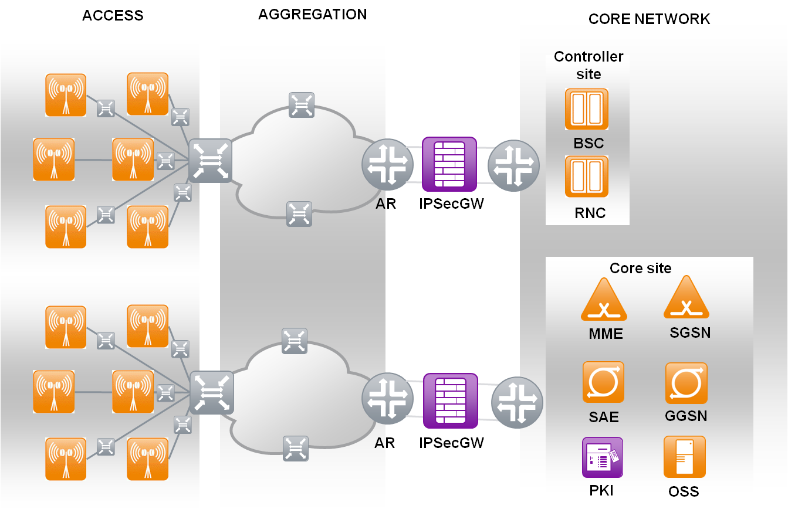

**Figure 11:** Positioning IPsec-GWs[6] at the aggregation points between core and mobile access transport, and “inline” between AR and the core network PE.

Advantage of this design is that all traffic has to pass the IPSEC Gateway and thus there is a natural physical security barrier between the aggregation layer and the core network. All interfaces on the IPsec-GWs are usually 10G. Depending on a customer’s expansion plan these interfaces will scale by bundling several physical interfaces to an 802.3ad link aggregation group.

Each IPsec-GW node will be connected to an AR site and core network router. Nokia Siemens Networks is assuming that there will be dedicated L2 connections between both routers and IPsec-GW. So that the IPsec-GW can provide a virtual IP as next hop address towards AR and core router.

The routing between the three systems can be implemented based on static routes or by using dynamic routing to ease the route distribution in case that new components will be introduced in either RAN or Core network. Customers have to be aware, that in this scenario the existing routing between AR and core router may need some reconfiguration due to the introduction of the IPsec-GW. In addition the integration of the IPsec-GW into an existing network will require a short service outage as the cabling between the components needs to be changed.

These are the main disadvantages from our point of view and compared with the scenario which is described in the following section.

#### IPsec-GW attached to RAN aggregation router

In this scenario the IPsec-GW is placed alongside the AR with both interfaces (incoming and outgoing) directly connected to the aggregation router, as shown in the figure below. Same as in the previously described scenario, all interfaces are 10G and can be bundled to link aggregation groups. In comparison, attached IPsec-GW has the advantage over “inline” IPsec GW that only minimal changes on the already existing network have to be done.

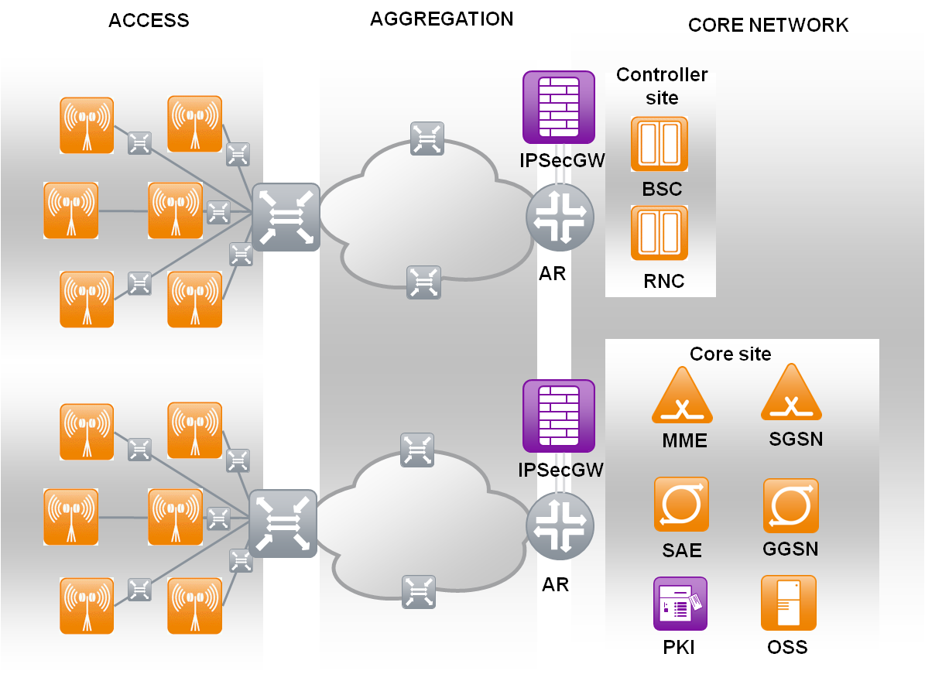

**Figure 12:** Positioning IPsec-GWs at the aggregation points between core and mobile access transport, and attached to the AR.

This scenario allows for aggregation of all interfaces between AR and IPsec-GW into one logical link. Once interfaces are aggregated the different kinds of traffic can be separated on Layer 2 by defining corresponding VLAN interfaces on the IPsec-GW. This solution will provide a higher level of flexibility and resilience against single link outages, however it should be discussed with customers from a security perspective as IPsec-GW can be bypassed by reconfiguration of AR.

As in the other scenario a virtual IP address will be provided towards the AR. The connection between IPsec-GW and core network depends on the final architecture and can be either L2 or L3 (using the AR as hop in between). Again, routing can be implemented based on static routes or by using dynamic routing between IPsec-GW and AR.

If the connection between IPsec-GW and core network router is based on L2 and if there is dynamic routing already implemented between AR and core network router this routing has to be reconfigured. If the connection between IPsec-GW and core network router is based on L3 (with AR as next hop in between) there is no change in dynamic routing needed on the existing devices. Hence, this should be the preferred solution from our point of view.

As an option the IPsec-GW can encrypt injected routes for BTS addresses and thereby smoothen migrations from a non-IPsec to an IPsec configuration.

### IPsec GW placed in front of the Packet core network

As a 3rd option the IPsec-GW can also be placed independent of the physical aggregation layers within the actual core network e.g. in front of the packet core elements, or at Controller sites along with RNC/BSC (It might quite often, but not necessarily always be the case, that the locations described in 3.1.1 fall together with controller sites!). IPsec-GWs concentrate more BS when they are positioned “higher up” in the network hierarchy; hence, VPN planning must consider the limitations regarding scalability and performance of the IPsec-GW. Depending on overbooking in the transport network and other factors like required throughput per Base Station or the number of SAs, a single IPsec-GW usually handles between “many dozens” (200-300) Base Stations up to “over 1000” (e.g. currently Juniper SRX 5800 hard limit is 1200)

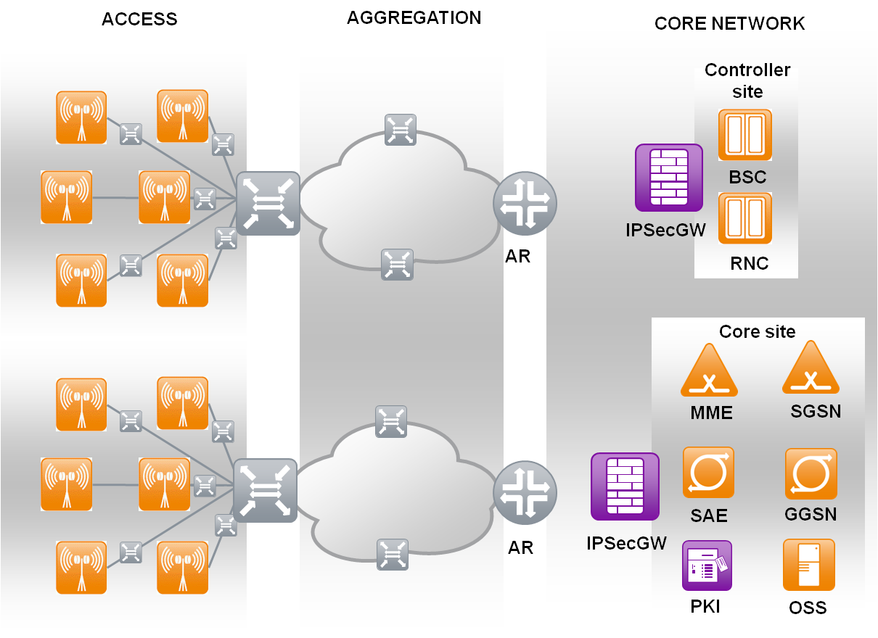

**Figure 13:** Positioning IPsec-GWs inside the converged core network.

An advantage of co-locating IPsec-GWs with Controller or Core-network equipment is that existing equipment can be re-used, or that the IPsec-GW can be used for “multiple purposes” as e.g. site-FW. However, there are good reasons also, to avoid such scenarios since the overall scalability of the design and the performance of the IPsec-GW might suffer!

* It has been mentioned in several passages of this document, that the planning of the VPN for IP Transport Security should be done in a holistic approach, including all technologies and BS types. This approach might be contradicting a strategy of plainly reusing “*what is anyway there*”. In order to keep transmission costs low and protect the investment made into security technology, it is needed to thoroughly analyze the existing topology and optimize different parameters, not only the CAPEX for equipment.
* Usually an RNC or BSC will have an existing site router that often *could* serve as IPsec-GW in a second function. Real Core network sites with MSS or SGSN/MME equipment will have bigger routers for VoIP interconnects etc. that could fit this definition as well. Such “mixed usage scenarios” can sometimes be useful and make sense from an economic perspective. However, they generally tend to organic growths rather than well-planned scaling. Mixing functions within one “*box*” creates interdependencies and increases operative risks. Problems in one function may easier influence other functions sharing the resource. Further, configurations become more complex and troubleshooting will take more time and effort.

We recommend a deployment of this scenario only in smaller networks, where the amount of BS that is concentrated in one Core site is not higher than what the IPsec-GW can handle. If several IPsec-GWs have to be deployed on one site, the Geo-Redundancy factor worsens and the scalability decreases. Further, the common hub-and-spoke topology will usually demand higher transmission cost if a “longer” path is taken across the aggregation layer and all way up to the core. It is generally easier and requires less transmission, if the IPsec-GWs are at an aggregation hub or Controller site. In the latter case, it is strongly discouraged from putting too many functions into RNC/BSC site routers!

A good use for this scenario might be pure L2 VPNs where all transport between BS and Core sites is handled without L3 functionality.

### IPsec-GW Redundancy

It is usually planned that two systems will be deployed at one site to provide resilience against hardware and software failures on one IPsec-GW component. The cluster is acting in active/passive mode meaning one system will process all traffic while the other node will be used in failure situations only. Both nodes will be visible to the outside world by the same (virtual) IP addresses. That means that the VPN connections between BTS and IPsec-GW will be established using the virtual IP the active IPsec-GW will provide towards the MBH. Virtual addresses towards the core network router will be used as next-hop to route all traffic to be encrypted from the core towards the IPsec-GW.

Each cluster could also work in an active/active mode. In this case the cluster would be configured in a way that nodes would be active and two virtual IP addresses would be provided, one active on each node. Both nodes would backup each other, i.e. if one node would fail for some reasons both virtual addresses would be active on the other one. VPN tunnel splitting on an active/active cluster must be configured manually by dedicated assignment of each BTS to one of the virtual RAN-IPs.

From a functional point of view there is no difference between active/passive and active/active. All features available in an active/passive are available in active/active as well. All requirements the system meets in active/passive will be fulfilled in active/active as well.

Benefits of an active/active configuration:

* Lower system utilization on each cluster node
* Higher throughput per cluster
* Lower latency
* Traffic peaks which would lead to over-subscription in an active/passive environment can be covered.
* Only half of the number of tunnels will be affected in case of failover.

Disadvantages of an active/active configuration:

* Risk of overloading in failure situations
* Configuration (esp. clustering and routing) is more complex.
* OAM aspects are more complex because of both systems being active and carrying traffic (e.g. system maintenance without service outage, upgrade/update scenarios, etc)

Since customers do usually not accept any service degradation during node outage an active/active cluster has to be sized in a same way as an active/passive cluster. Each cluster member must be able to handle the entire traffic in case of failure. This means that no reduction in terms of equipment can be achieved when using an active/active scenario.

Thus, Nokia Siemens Networks is recommending the less complex active/passive scenario.

However, we are more than willing to support our customers with an active/active solution as well, if desired and given the above mentioned restriction.

In general each IPsec-GW node is tracking the physical links towards the connected routers. A failover will be triggered in case one of these links is going down. In addition, the state of several system components (Routing/Supervisor Engine, processing cards, IO cards, switch fabric) as well as the overall system state is monitored permanently and a failover will be triggered if one component fails.

If required, the connectivity to the next-hop routers or specific IPs can be monitored. However, as long as the connection between IPsec-GW and AR/core network router is based on L2 and link status monitoring is activated Nokia Siemens Networks does not see any need to do any additional monitoring on L3.

All VPN and session state information will be replicated between cluster-members in both, active/passive and active/active modes, to ensure that the backup system will have all session information available in case of failover.

Separate physical interfaces will be used for cluster interconnect. These links will be redundant as well so that the IPsec-GW solution does not contain any single point of failure.

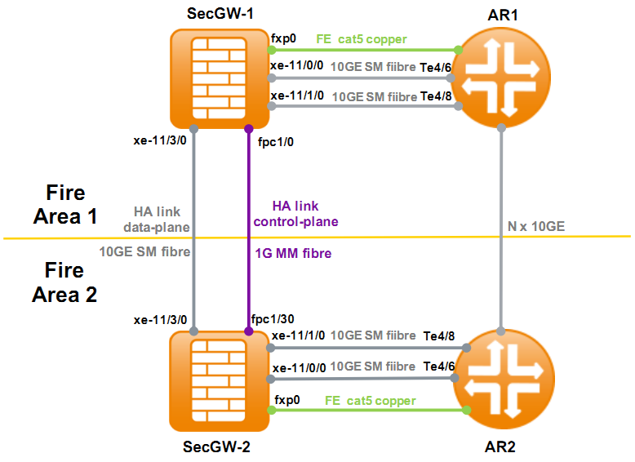

**Figure 14:** Typical deployment for IPsec-GW (2N attached to AR).

### Tunnel Deployment Options

NSN Customers often request a solution where all BTS originated VPN tunnels terminate at the IPsec-GW on one and the same virtual RAN-IP address. This is technically possible. However, Nokia Siemens Networks is recommending a different proposal which is about splitting of Base Stations into different groups. For each group a dedicated virtual IP address should be configured on the IPsec-GW as VPN tunnel endpoint. This approach allows for:

* More flexibility in case of future expansions
* Moving BTS to a different IPsec-GW without reconfiguration
* Easier IPsec-GW platform migration
* The detailed VPN design mainly depends on the IPsec feature-set of the BS and differs among vendors and radio technologies. There are two different architectural approaches to configure the IPsec tunnels between BTS and IPsec-GW Both will be described more detailed in the following sections and need to be further discussed before starting the implementation.

#### Single-tunnel architecture

The single-tunnel architecture scenario carries all traffic (UP/CP/MP) inside a single VPN tunnel, terminated on the IPsec-GW. The figure below illustrates the proposed architecture to use a single tunnel based on an example of the three different traffic classes used in an LTE network.

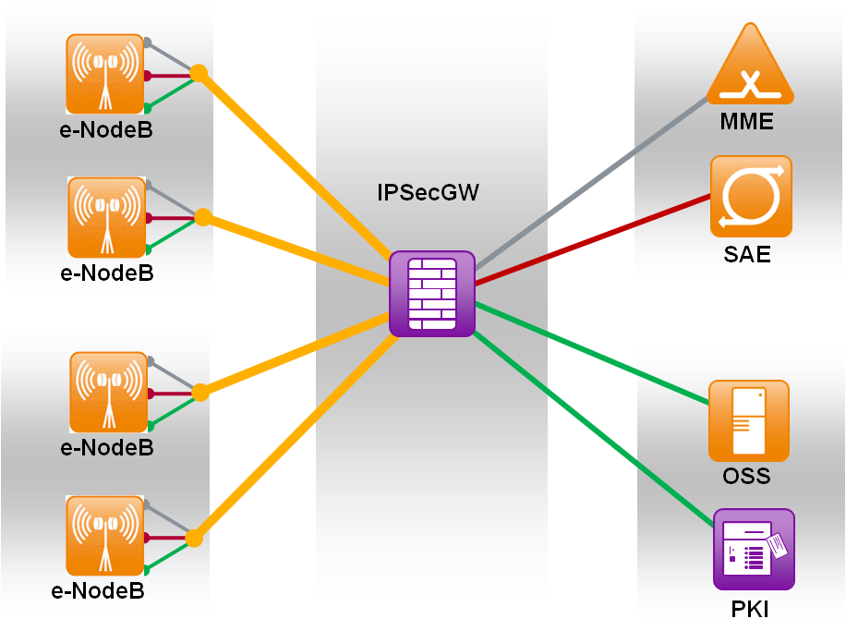

**Figure 15:** Single tunnel deployment (all traffic inside one tunnel)

The BTS will establish a single tunnel towards the IPsec-GW and will use this tunnel to encrypt all kinds of traffic (CP/UP/MP). The authentication of both peers will be done by using digital certificates issued by the PKI system.

Optionally each traffic plane can be encrypted separately by using different algorithms for encryption and integrity protection. In addition virtual routing instances can be implemented on the IPsec-GW to separate the different kinds of traffic.

The BS chooses its encryption-set based on a combination of source and destination IP, encrypt the traffic and forward it towards the IPsec-GW. The IPsec-GW will decrypt the traffic and will forward it based on its local routing table towards the core systems. Packets from the core towards the base-stations will be encrypted based on either using static routes (pointing to a specific IPsec tunnel) or by access control lists configured on the IPsec-GW.

#### Multi-tunnel architecture

In the 2nd scenario each BTS establishes a VPN tunnels per plane terminating on different logical interfaces on the IPsec-GW. This means that the traffic planes are totally separated from each other.

The figure below shows the proposed tunnel architecture based on an example taken from an NSN iHSPA environment.

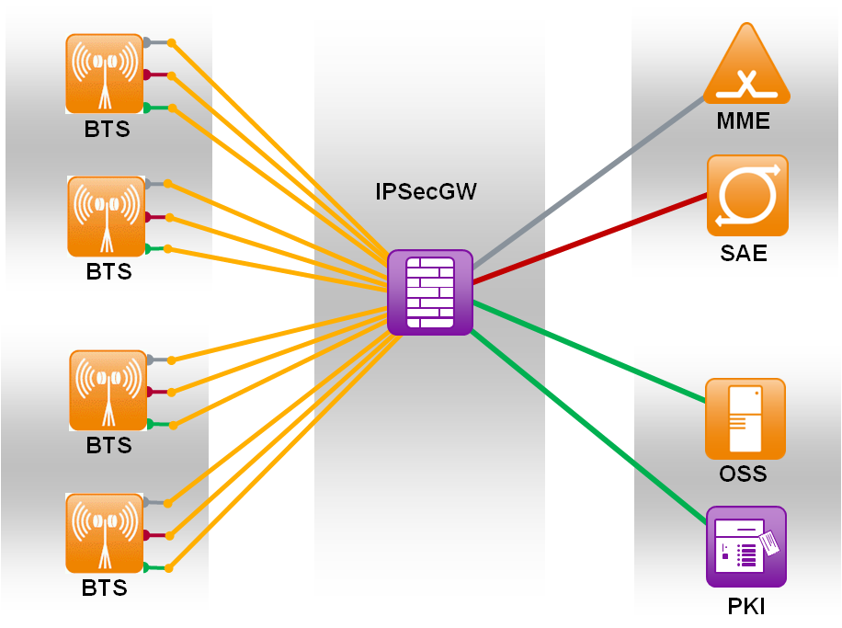

**Figure 16:** Multi-tunnel deployment (each plane inside a separate tunnel)

#### IKEv1 versus IKEv2

Although the first RFC for IKEv2 was published already in 2005, several updates have followed since and the currently latest version is dated only to September 2010. Hence, it is not a matter of course that all vendors have mature and well tested IKEv2 implementations for their IPsec stacks! NSN has done thorough testing of all scenarios and for both, IKEv1 and IKEv2 with all components of the Transport Security solution. Besides legacy GSM Software, all NSN BTS support both, IKEv1 and IKEv2.

In 3GPP 33.210 it is required, that IPsec-GWs shall support both versions, IKEv1 and IKEv2. However, “*as the use of IKEv2 has* *certain security and performance advantages over IKEv1*” (wording taken from the specification text), 3GPP clearly favors and encourages the use of IKEv2 in cases when both are supported.

There is a certain drawback in this recommendation, and it should be considered well when planning networks: IKE is also used to provide so-called re-keying, a renegotiation of temporary session-keys that happens usually once in 24h. IETF specifications for IKEv2 (i.e. RFC 5996) require, that for such re-keying the connections (i.e. the child-SA) are re-established, in clear: connections are reset. In the focus of IKEv2 – which is mainly a simplification of Remote Access VPN scenarios – this behavior makes sense. One reset on a user’s VPN connection in 24h is totally acceptable. In site-to-site VPNs where thousands of BSs connect to an IPsec-GW, one reset in 24h for each of the tunnels might be not acceptable for customers!

To encounter this problem in the specification, NSN BTS that support both IKE versions do also offer an alternative and optional IKEv2 IKE re-keying mode that avoids the packet loss at the cost of re-authenticating the BTS again.

## Deployment of the PKI

Since the PKI is the key component of the strong authentication mechanism of the Radio Access Transport Security solution it has to be hosted in a central and protected location. Mind, that not the certificates issued by the PKI are the asset that needs protection, but the keys of the CAs by which the BS or other EE pub-keys are signed! Any compromise to the PKI system or to the keys of its CAs will destroy the trust-model and require a renewal not only of the CA certificates and keys. It will also invalidate all certificates that have been previously issued by such a CA!

Therefore, the PKI is deployed in a model of several vertical and horizontal security layers. Regardless if CMP or other certificate Management traffic from the RAN is going through an IPsec tunnel or directly sent to the PKI, it has to pass a series of FW filters.



**Figure 17:** Deployment of the PKI in the operator network

The PKI itself will be located in a central site, normally close to the management system OSS. This site is protected by a site-FW. Vertical traffic separation allows that different BS types or BS with different initialization status are handled differently in that site-FW. For example, initialization requests from new BS can be handled differently than update-requests or CRL downloads from BS or IPsec-GW nodes that already have enrolled for a certificate. Each vertical traffic layer is separated into an own VLAN and IP address range hence it can apply to different rules in the site-FW. For each “vertical” service, a server must be configured in the PKI Frontends (FE).

Horizontal traffic separation is implemented by a cascade of filters in the site-FW and on the PKI hosts (iptables). Each request must pass the entire row of filters or it will be “stuck”. Termination of all service protocols – CMP, OCSP, LDAP, web-based CRL download etc … – is done in the FE. From there, request “payload information” is extracted and dispatched to the BE via a PKI internal TLS connection. This TLS connection must pass the outbound iptables filter of the FE, then the site-FW again and finally the inbound iptables on the BE. It would therefore require an attacker to “punch holes” into several firewalls in a row before being able to reach the signing CAs from a RAN IP address. It is a common good practice in security, to build such rings and layers of protection around an important asset.

# NSN Secure Identity Delivery Process (SID)

X.509 public key certificates are a well standardized, mature method to provide an electronic identity for “*Subjects*” or “*End Entities*”. A Subject can be any human that wishes to sign emails with digital signatures, or also a BS that needs to prove its genuine origin from a certain vendor or factory in a machine-to-machine communication. Subjects become End Entities from the perspective of a Certification Authority (CA) that signs their public keys and issues a certificate. This process comprises mainly 2 ideas:

* The certificate must irreversibly connect a public key to solid Subject information that can’t be changed by the subject, like a human person’s ID card or the S/N of hardware. This connection is confirmed by a CA when it digitally signs both, public key and subject information, with one digital signature over both pieces of information.
* The signing CA must be sure without doubt, that the public key and subject information truly and inseparably belong together! When trusting a certificate, the “accepting end” shall have assurance, that the CA is trustworthy and doing a *good job* when making exactly this connection! Otherwise, the certificate is useless! Further, accepting a certificate implies that one trusts the private key used by the CA. It must be available only to that particular CA and can’t be copied to issue fake certificates.

NSN Secure Identity Delivery process aims to allow operators, to manage the identity of their BS by X.509 certificates, so-called *operator-device-certificates* or simply *operator-certificates*. For this purpose, operators must have a PKI with own certification authorities in place, e.g. NSN Insta Certifier PKI platform as part of the transport security solution that is described in this document. But deploying thousands of operator-certificates to BS that are spread around sometimes huge geographical areas brings some logistic challenges.

An intuitive approach to solve the logistics problem on the operator side could be, to install a certificate signed by an operator CA directly in the NSN factory when the BS is assembled. When it then connects to the operator network, it would directly be recognized by a certificate signed under the operator’s certification authority. However, a deeper discussion of this procedure would show that it only shifts the logistic problem from the field-deployment to the production process and that still a wide room for tampering is possible, before it can be ensured, that proper BS with the correct certificate is delivered to the right location.

3GPP has defined a better way to start the “chain of trust” already during the production process, and then hand it over to the operator CA. According to the combined descriptions in 3GPP 33.310 and RFC4210, X.509 public key certificates can be used as “external identity certificate” to authenticate BS when enrolling for a certificate with another, second CA. In NSN Secure Identity Delivery, the first certificate is a “*vendor-device-certificate*” or simply “*vendor-certificate*” that is implanted into the BS during manufacturing in an NSN factory. This first vendor-certificate is then used during BS rollout to identify a BS as genuine NSN BS when it applies for an operator-certificate.



**Figure 18:** Simplified view to NSN Secure Identity Delivery Process (SID)

All new 4G – i.e. LTE and I-HSPA BS – are delivered with a built-in vendor-certificate that identifies the BS by its S/N in the certificate subject field. The vendor-certificate can therefore be seen as an identity of the BS[7], it identifies the BS as genuine NSN manufactured Hardware. By the S/N in the certificate subject, the certificate can be mapped to one particular BS. The NSN CA that signs those vendor-certs is hosted by a 3rd party provider BBS-Nordic and the certificate request – i.e. the keypair for the vendor certificate on the BS – is created as part of the production process of the hardware. In the NSN factory, a Registration Authority (RA) receives the public key, connects it to the S/N and signs a CSR, which is then sent to the centralized CA in BBS Nordic. Only requests of authorized RAs are signed, hence, it requires to compromise the entire production process in one of the factories in order to gain a fake vendor certificate. Both sides – BBS Nordic and NSN factories – guarantee for the security of the signing process on their end.

Once the BS has its vendor-cert installed, it can be shipped to any operator. Along with the delivery of the hardware with the built-in certificate, NSN customers will receive a list of S/N of the purchased BS entities and the NSN vendor-CA root-certificate. With the vendor-root-cert, operators can verify the authenticity of vendor-device-certificates in their own operator PKI. Once a BS is authenticated, it can enroll for an operator-certificate signed by the operators own CA. Thereby, the operator takes over the authority of issuing, revoking and managing the BS identity.

This process creates an inseparable connection between a BS and its certificate, starting in the factory and inherited without any leakage of security information towards an operator CA. Mind, that the vendor-root-CA cert of the NSN factories is not security-critical as such. But implanting a false trust anchor into the operator PKI can seriously harm the trust model of the entire rollout. Therefore, the NSN root-cert is not secret material, but it must be checked, that exactly the correct and no other than the NSN vendor-CA root-certificate is installed as Trust Anchor! The result of this process is that the BS’s are secured from the moment they leave the factory up to the moment they are taking out of service due to reaching end of support.

## Initial Registrations of BS to the Network

Initial registration or “initialization” of a BS means, that a fresh keypair is generated and the public key has to be sent to a CA to enroll for a new *operator-certificate*. This will create the identity of a BS in the operator CA and is in contrast to e.g. key-updates, where a new keypair is sent to replace an old one. In replacement, the identity (the X.509 Subject Name) is not new to the operator CA and an operator-certificate is only renewed, but not issued for the first time as in initialization!

During an initialization, it is important that the EE/BS authenticate to the operator CA from which they want the certificate request signed! Because it must be made sure, that not “just any device” could enroll a public key and act as genuine vendor BS in the operator network. With the PKI solution as deployed by NSN, we apply different authentication methods during BS initialization. It is target of all initialization procedures – regardless of the applied authentication method – that the BS receives an operator certificate.

### Registration for BS Nodes with Vendor Certificates

In newer 4G BS, like LTE eNB and I-HSPA, the BS is manufactured according to the NSN Secure Identity Delivery Process as described in Section 4 of this document and it can use vendor-device-certificates to register for an operator certificate.

When a 4G BS boots up, it will see that it has no operator-certificate, but a vendor-certificate. It then issues a DHCP request, in which response the DHCP vendor-options fields contain

* The IP address of the PKI, more precise, of a CMP service from which the operator CA can be reached to enroll for an operator-certificate.
* The IP address of NetAct, from where in a later stage of the SON/PnP enrollment the BS can download its remaining configuration.

Below Message Sequence Chart roughly outlines the communication between the PKI and the BS:



**Figure 19:** Initialization with vendor-device-certificate authentication

#### Vendor root-CA Trust Anchor

NSN has to deliver the root-CA cert of the vendor-CA to the operator who purchased the BS hardware. This is needed, so that the operator CA can verify the vendor-device-certificates used to authenticate requests for operator certs. Since normally a PKI for Network Elements will never be connected to the Internet, the trust anchor / NSN vendor CA root-cert has to be transferred to the PKI in an offline channel. For example, the operator can download the certificate from NOLS or NSN project management will provide the certificate, e.g. as PKCS file.

#### Optional Serial number Whitelist

As an additional precaution on top of the Vendor certificate verification, NSN (or any other BS vendor) can also deliver an XML based list containing the S/N of the equipment under scope of the rollout. This file can then be used as a whitelist. An issuing CA does cross-checks the whitelist, if a BS that asks for an operator cert is not only a genuine NSN BS, but indeed eligible to obtain a vendor certificate! Such an extra-check protects operators – for example – from issuing certificates to BS that have been stolen from the NSN factory or from another operator.

The format of the S/N list is simple and XML-tags have to be as depicted below. Serialnumbers as such – between the <SerialNumber> tags, can have any format.

<SerialNumberList>

<SerialNumber>L6094954687</SerialNumber>

<SerialNumber>L6093734797</SerialNumber>

<SerialNumber>L1101401103</SerialNumber>

</SerialNumberList>

**Figure 20:** XML whitelist to cross-check if S/Ns are eligible for operator certificates

### Registration for Legacy Nodes without Vendor Certificates

If BS are already deployed in the field for a while and do not come with a vendor-device-certificate, the above described method 4.1.1 does not apply. Nevertheless, all BS have to be authenticated since issuing of certificates to rogue EEs imposes a major risk in the secure rollout procedure.

In RFC4210, a second, alternative method is specified to authenticate certification requests based on a shared secret (PSK) and a reference number that belongs to each PSK. It requires that the PSK is transferred to the BS by an “out-of-band” method. Practically stating, that operators have to generate an EE within Insta certifier, and to this EE a “refnum” and “PSK” are assigned. When the CSR is formulated in the BS, it will sign the public key with the PSK and send it along with the reference number. Thereby the Insta certifier is able to verify, if the key/request has been sent by the expected BS, who is the only instance that can know the PSK.



**Figure 21:** Initialization with out-of-band PSK and refnum authentication.

The method can be applied for all NSN BS in radio releases RL10/RU10 onwards and is supported by Insta certifier as well as by other major PKIs. However, Insta allows, that the same PSK/Refnum can be reused for a configurable amount of times, allowing for flexible ways to implement the out-of-band transport.

#### Out-of-band PSK transport and PSK use-count

It should become clear by the above that the PSK/Refnum combinations have to be generated on the PKI and in the next step to be configured on the BTS. Configuration of PSK/Refnum and triggering of the init procedure by an “external” method (external = outside the BS and outside the PKI) are separate steps and they are not related!

Operators have the flexibility of either creating a new PSK/Refnum for each single BS to be enrolled, or alternatively configuring a higher use-count >1 and reuse the same EE, hence same PSK/Refnum, for many BS. Each approach has advantages and disadvantages:

Scenario 1: Reusing the same PSK/Refnum

In Insta Certifier, creation of an EE will automatically assign a PSK/Refnum that is usable for authentication during enrollment. If – for example – 500 BS have to be enrolled during one day, the “use-count” of the PSK/Refnum for this EE is set to 500. That means, each single BS that sends a request according to will use the same PSK/Refnum for its request and all – or better: the first 500 BS – will receive an operator certificate in response. This is opens a certain door for abuse, because any EE that knows the PSK – regardless if genuine NSN or other BS – will be able to obtain a certificate with the same PSK/Renum as the other 499 BS are using. For this lack of security, the method is easier to implement and has lesser administrative overhead.

Scenario 2: Creating individual PSK/Refnum per BS

Instead of reusing a key for 500 BS a corresponding number of times, it is possible, to create 500 BS where each BS shall refer in its request to a different, individual PSK/Refnum. This method is much safer, but it requires significantly higher administrative overhead. Not only that the 500 EEs have to be created (instead of only one EE as in the Scenario 1). Much heavier weights the coordination of the BS installation: If individual EEs are used, consequently, operators will also demand that each EE requires to be created with an individual attribute of the certificate to be mapped to, for example, S/N or IP-address/FQDN. This means, that the field technician or program that triggers the initialization must not only know the individual PSK, but that also some entity assigns the right list of BS along with the right PSK/Refnum to the right field technician for site installation!

### NSN certificate deployment service

Above scenarios 1 and 2 implicate, that the deployment of certificates to a large installed base is not trivial, a completely secure and tamper-proof procedure requires detailed system knowledge. If this task is not accomplished properly, the new security model could be endangered from scratch and investment protection would not be for guaranteed.

NSN CSI security offers therefore an optional service to deploy the certificates to the operator networks installed base of legacy BS that do not have vendor device certificates. This service can be purchased along with the deployment of an Insta PKI and it guarantees that no security relevant information needs to be shared with engineering staff in an undefined trust relation.

Generally, but depending on individual operator conditions, NSN chooses an approach that is roughly depicted in to implement a trusted out-of-band channel and trigger the enrollment:

1. NSN CSI staff will comb through the operators NetAct database and prepare a schedule by which an agreed and defined number of BS will be enrolled.
2. Next, scripts are written to process the agreed lists in order to

* Create the needed EEs along with individual attributes and map PSK/Refnum to each EE. This step happens in Insta certifier
* Next, the lists are processed from NetAct where the EEs are known as managed objects in the NetAct database. In a secure connection, each EE will be contacted and an initialization with the correct PSK/refnum will be triggered

Work effort and complexity depend very highly on the operator network structure and eventual additional requirements. An offer based on according estimations can be obtained via the NSN account team

### Manual and alternative certificate registration methods

There might be individual cases, where neither authentication using vendor certificates (see 4.1.1) nor authentication by PSK/Refnum (see 4.1.2) is possible. For example, if NSN Insta PKI solution is not in place, if no connectivity from the RAN to the PKI can be established during site commissioning or if the BS is 3rd party and do not support CMP protocol. Such situations should be exceptions and a secure and cost-efficient rollout should always be based on previously described, standardized methods. However, if exceptions require deviations from those methods, one of the following 2 alternative methods could be used. Mind, that both methods are not suitable for mass deployment and only thought to overcome problems that might otherwise delay a rollout.

#### Manual Certificate deployment

Previously described procedures benefit from an automatism that eliminates necessity of sharing information with human individuals. Authentication of the BS as well as generation of the key-pair and initiation of the signing request (CMP certReq and IR messages) are triggered completely without or with minimized human interaction, and without direct access to security relevant information.

If no automatic procedure can be applied, there is still the possibility, to have human staff perform the actions and transfer data in any desired channel between participating computer systems. A completely manual deployment of certificates can follow the below outline:



**Figure 22:** Manual deployment of certificates by a human operator.

In the depicted process, a human operator will be equipped with a list of BS which needs to have certificates deployed. (S)he will create a CSR for each element in the list and the PKI will create an optionally password protected PKCS file, containing the actual certificate and the required root-certs of a trust chain, plus the private key of the certified EE. This file will then need to be transferred “by any means” to the BS/EE and activated.

Mind, that the description of the procedure given here is a very rough outline, and that it might differ slightly in its execution and even significantly in its security implications: In the given picture, a PKCS#12 file is generated, which contains the private key of the BS. A fact implicates, that the private key is not generated on the BS itself and hence a wide range of tampering is possible here. In other scenarios, it might be possible, that the keys are generated directly on the BS and a different (e.g. PKCS#10) format is chosen to transfer the request without exposing the private key to tampering!

Using manual deployment results in a significant decrease of security and a massive increase of manual and logistic steps to be performed! As such, the manual procedures are pure workarounds and it is highly recommended to use the automated procedures!

#### Default-Installed Self-Signed BS Certificate

Another alternative method that is specific to NSN BS is the emergency-use of a default, pre-installed and self-signed certificate (DI-certificate). A BS uses the DI cert for CMP if a initialization is triggered, but no PSK/Refnum configured and no vendor certificate is available. The DI certificate is not used between BSs or between a BS and the IPsec-GW![8]

All NSN BS have such a certificate installed, and it is useful in situations, where a protocol requires the existence of a certificate, while on the other hand no certificates (could) have been created at the current stage of operation. From a security perspective, a DI certificate does of course not allow a reasonably strong authentication of a BS because the DI could have been copied from anywhere along with the private key, which is the same for all BS.



**Figure 23:** Using DI self-signed certificates for authentication.

Mind, that usage of the DI by the BTS does not mean that the peers need to accept it! It is up to the RA/CA and operator policies, if DI is allowed to authenticate a BS for certificate enrolment. A CA could be configured that it never accepts the DI cert, that it always accepts the DI or that it accepts it only in exceptional cases.

However, if no vendor certs are in place, it is strongly recommended to use PSK/Refnum instead the DI cert! The idea what a certificate implicates, see 4, is very much eroded by certificates that can’t be mapped to individual information of a subject.

# Security Gateway Platforms

In the current Solution release, NSN supports 2 different Security Gateway (i.e. IPsec-GW) platforms, the Juniper SRX as a native security appliance and the Cisco WSG, which is a processor extension to the widely used 7600 series multi-service switching platform. Both variants are fully tested for IPsec interoperability with NSN Base Stations and for interworking with the PKI solution.

## Juniper SRX

Juniper Networks SRX Services Gateways provide a carrier-grade chassis based solution for IPsec VPNs. The high-end model SRX5800 has 12 slots that can be used for either IOC modules (traffic interfaces) or SPC modules for service processing (i.e. IPsec). Two Control Boards (SCB) handle the HA and control plane functions. SRX systems IPsec capacity scales along the amount of SPC cards inserted! IOC modules are normally 10Gbps Ethernet, work at line speed and can be aggregated into 802.3ad link bundles. Alternatively, 40x1Gbps Ethernet IOCs are available. Each IOC has 4x10Gbps connections towards the backplane, so that the full capacity of each card can be used. Below Figure shows the SRX5800. A smaller model (SRX3000 series) is available in order to provide scalability on solution level.

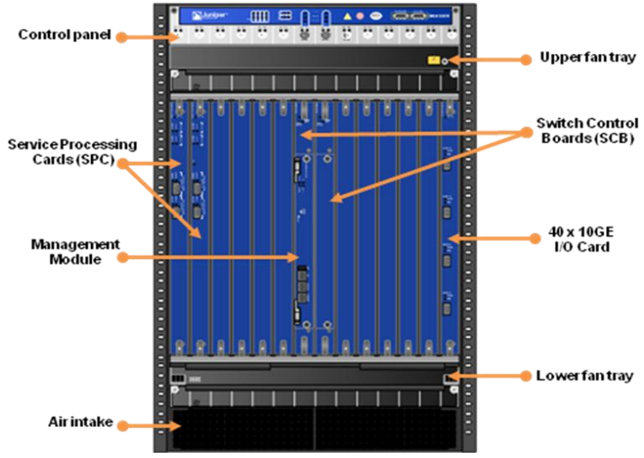

**Figure 24:** SRX5800 chassis with IOC and SPC modules deployed.

In its physical specification, the SRX requires 18U height in the rack and can weight around 160kg when fully configured. Power consumption does also depend on the number of supplied SPC and IOCs, a fully configured chassis will require around 5kW @48VDC and produce approximately 17.000 BTU/hr of thermal output.

A complete description of the SRX5800 and datasheet can be downloaded from the Juniper webpages:

<http://www.juniper.net/us/en/products-services/security/srx-series/srx5800/>

## Cisco WSG

The Cisco 7600 series is widely known as a multi-purpose and multi-service platform. It sees huge deployment for various purposes and is most commonly deployed in the 7609 variant with 9 slots.

Cisco’s “Wireless Security Gateway” is a carrier-grade IPsec-GW application that runs on a so-called “SAMI Blade” (*Service Application Module for IP*). A SAMI is a power-PC based full-sized card running IPsec SW and providing Firewall filtering. In “normal” 7600 setups, a Supervisor Engine in one slot handles the control plane and platform functions while Linecards in the remaining slots are providing the physical interfaces. For WSG setups, an additional internal VLAN is configured for the communication between SAMI and supervisor. Via routing, the protected traffic from the converged core as well as encrypted traffic from the RAN are both pointed towards the WSG VLAN interface. Several SAMIs can be inserted into one 7600 series’ housing.



**Figure 25:** SAMI blade and Cisco 7609-S chassis with Linecards.

Each slot of a 7609[9] can hold one full-size card; hence, after the supervisor engine is supplied there are 8 slots available for either SAMI or Linecards.

In NSN 3G Radio Networks, the 7600 is deployed as a Site-router for RNC sites and if there are available slots to fit SAMI modules, it is possible to jointly use the devices as RNC site routers and IPsec-GW. However, the constraints and difficulties that are included in such a scenario must be thoroughly considered. See also paragraph 3.1.2 of this document.

The physical dimensions of the Cisco chassis are absolutely comparable to the Juniper SRX: A fully equipped chassis weights around 125kg and with two (in the redundant configuration) 6kW Power Supply Units it produces around 1500 BTU/h per equipped slot.

A complete description of the WSG and datasheet can be downloaded from the Cisco webpages:

<http://www.cisco.com/en/US/prod/collateral/wireless/wirelssw/ps10346/data_sheet_c78-532047.html>

## Performance limitations of the IPsec-GW

Several tests of independent bodies have attested highest performance and reliability to the SRX5800. Cisco WSG did catch-up with its release 3.0 and can provide comparable throughput. However, at the time of creation of this document, only WSG release 2.0 is available and its capacity is clearly behind that of the SRX5800.

It is important to measure performance figures of any IP appliance against the traffic patterns it has to serve. And it is particularly difficult to compare Firewall capacities named by different vendors. For example, some major vendors describe the throughput of an IPsec GW by a value where only one direction of the traffic – outgoing or incoming – is encrypted (instead of both directions). Also, the assumed traffic mix and the packet size or the used encryption algorithm and key-lengths have significant influence on declared and advertised figures.

It is a better dimensioning approach, to break capacity into the number of BS that an IPsec-GW can support and then scale this number along the amount of HW, e.g. of SPC cards the SRX has. The more SPC cards are inserted, the more processing capacity for IPsec and Firewall filtering is provided. Similar is valid for Cisco WSG: The more SAMI blades are inserted into the Chassis, the more tunnels can be handled.



**Figure 26:** Example capacity calculation for LTE eNB supported in one SRX 5800.

Above figures are based on experience in worldwide Nokia Siemens reference projects, and should give an example how SRX5800 IPsec-GW performance is scaling over LTE eNBs that it can support. It is important to note, that those performance figures are based on “field experience” with LTE traffic and Multi-Vendor LTE radio. Due to NSN’s leading role in LTE transport and security deployments, we are able to define very accurate dimensioning!

With above figures and based on NSN field experience, a fully equipped SRX 5800 active/standby cluster can hence provide between 18-20 Gbps full duplex IPsec traffic for an LTE network. This corresponds to *at least* 130 pcs of LTE eNB that one SRX5800 can support[10].

“*At least*” means, that the number will be significantly higher, depending on the overbooking that is allowed in the MBH transmission! Assuming too low overbooking is unrealistic and expensive, since not all eNBs will be fully utilized at the same time. Assuming too high overbooking results in bad service quality and network performance problems. It is a planning decision to find a proper tradeoff. Above table shows the number of LTE eNBs over the number of SPC cards in one SRX, where each line corresponds to a different overbooking factor. For example, if the overbooking factor is 6, 9 SPCs can support 750 peak-site-rate eNBs while an overbooking factor of 8 can be assumed to support 768 eNB with only 7 SPC. With its release 3 which is currently under test, the Cisco WSG will have very similar throughput values.

# Public Key Infrastructure Platform

For the lifecycle management of certificates in a TelCo operator environment, different requirements apply than they would e.g. in e-Business or end-user authentication. Such requirements concern both, software functionality and used hardware platform. For example, a user or customer with human intelligence might take different corrective actions when his certificate expires than a radio BS does. In turn, several thousand radio BS triggering automated actions might impose a different challenge to a PKI than users who are able to just press the button again in 15 seconds.

Our Radio Access Transport Security is based on the INSTA DefSec Oy Certifier® software product. NSN and INSTA DefSec jointly develop operator specific features and functions for the Insta CA software. In order to run the INSTA software in a TelCo operator environment, a highly availability scalable architecture is defined by NSN in agreement with INSTA. This architecture defines three possible deployments:

* A simple virtual machine setup to use for basic testing.
* A single-server “trial setup” without HA and traffic separation.
* A full HA setup using Linux HA and scalable traffic separation

In this document, only the full HA setup as deployed in production environments is described. For the alternative setups in trials and test-beds, installation documentation and support are available upon request.

## PKI Hardware Platform

For reasons of pricing, supported lifetime and quality, NSN has decided to base and support the NSN INSTA PKI platform on Oracle – former Sun Netra X4270 servers. In the given configuration the servers have following characteristics:

* 2 x Xeon L5518 quad-Core processor 2,4 GHz 8MB-L3
* 2U rack height, 18 kg weight / 1540 BTU/h / 450W
* 18 DDR3 slots, comes with 16GB equipped (8x2GB)
* 4 built-in 1Gbps NICs plus ILOM
* comes as 2x300GB SAS-2 disk, DVD, RAID

A complete description of the servers and datasheet can be downloaded from the oracle webpages:

[*http://www.oracle.com/us/products/servers-storage/servers/netra-carrier-grade/sun-netra-x4270-server-070754.html*](http://www.oracle.com/us/products/servers-storage/servers/netra-carrier-grade/sun-netra-x4270-server-070754.html)

On all servers, underlying Harddisks are configured in a RAID 1 (mirroring) on HW level with the Netra’s builtin SAS storage controllers. This is transparent to the filesystem layout under Linux, where disks are accessed via common SCSI drivers as labeled ext3 partitions.

## Scalable Software Architecture

INSTA certifier Software comprises 2 main components, which again are split into several, separately configurable items. Each item can be independently activated or deactivated. On Hardware scale, certifier is split into Frontend (FE) and Backend (BE). Purpose of the Frontends is, to terminate all protocols/services that come from EEs, such as CMP requests or LDAP/OCSP requests etc… In the Backend (BE) a built-in repository of all issued certificates is held in a Sybase SQL database. That same DB also holds the certifier configuration. Further, the BE provide the certifier engine which access private keys and performs signing operations under certificate requests or CRLs. Private keys are held either in the database as well (in an encrypted section) or in a separate Hardware Security Module (HSM).



**Figure 27:** Certifier scaling into FE/BE.

All Frontend services, CMP, Validation services etc … can be activated, deactivated or configured separately. In good-structured setup, each service should have an own HA-IP address and be situated in an own VLAN, so that services can be easier filtered in the perimeter Firewalls.

### Policy based processing

Major strength of the INSTA Certifier is its flexible and easy configuration towards how to handle certificate requests. Similar it is known from “iptables” functionality, each message goes through four different “chains”. As there is for example a chain “Receive Request” and a Chain “Accept Request”, both allowing independent configuration on how to handle situations of incoming or accepted requests. Within each chain, policy modules can be added and configured to define the behavior of the chain.

Policy modules allow various actions, as e.g. changing or removing of constraints, validity periods or verification of subject names against white-lists or configured end-entities. Approaching the complexity of certificate lifecycle management with a chain of separated and independent modules allows to configure the PKI very intuitively and flexible.

### Rapid setup and easy maintenance

NSN Insta PKI platform comes with 4 servers as described to provide a maximum of high-availability and minimum time to recover from failures. The number of servers is not at all defined through performance limits, the 8 CPU cores could carry more load than the PKI application normally imposes. Reasoning for the quite powerful hardware compared to the task is to provide a stable buffer for possible performance peaks, and to provide better security by allowing horizontal traffic separation over several layers between Radio EE and Certifier engine. The relatively moderate CPU utilization of the PKI servers will also result in low power consumption and lesser waste heat, so that nominal data as given in the data sheet will normally not be reached. Therefore, the investment into 4 servers is justified, rather than having a smaller solution for economic (OPEX / TCO) reasons, but resulting in weaker security!

Installation and initial configuration of the PKI are done in a “rapid-setup” procedure. During the installation planning, engineers will fill the required planning data such as hostnames, IP addresses to be used, routes, VLANs to be created on the servers etc… into an excel-sheet. This sheet will be transferred to a USB installation media and will be used by a fully automated setup procedure. Installation of a new HA-pair (2 servers) from scratch can be done <15min by trained staff. With all preparations done properly and experienced engineers in place, a complete installation from scratch until a fully configured system (4 servers) to issue certificates can realistically be done in <120min!

The certificate database is usually small, even with a high number of certificates (several 10k) a database size of more than few GB is rarely to be expected. Therefore, a re-building of a system from scratch or restore from backup can always be accomplished in minimum time, thus making the PKI system truly high-available at low OPEX!

## High Availability

In the full HA setup, 4 servers are used and connected as 2 redundant pairs, providing failover services for the Certifier functionality and for the Certificate repository. Each HA pair is hosted in a separate “Security Zone” and Perimeter Filters should be applied. IP address planning and VLAN assignment must support both, HA and secure traffic separation. (See also Sections 6.4 and 3.2 of this document, especially the security zones in ).



**Figure 28:** HA services in 4-server full-HA deployment (HAPF1.0)

In the current release of the NSN Insta PKI Platform – namely HAPF1.0 – the certifier engine runs in an active/standby configuration on the Backend. Switchovers are managed by Linux HA: When certifier services become unavailable on the primary BE, the IP address and certifier engine will be automatically activated on the secondary server. There is no need for a shared storage between the active and the standby server, as DRBD simply replicates the active database to a slave-device on the standby hosts SAS controller. Synchronization between the Thales HSM modules is done using a synchronization tool that comes along with the PCIe cards. When the engine switches over, the endpoint of the TLS connection from the FE remains “transparent” as the BE IP stays the same and the internal TLS certificate just switches along with the certifier engine. However, the engine itself restarts during a BE-switchover.

If desired by the operator, an LDAP directory can be held as additional certificate repository. In that case, the CAs in the backend can be individually configured to publish all certificates and CRLs into that LDAP directory. To avoid consistency problems, LDAP is not using its built-in replication, but also a mechanism based on Linux-HA in order to switch over if the LDAP service fails on the primary FE.

All IP addresses that can be seen by BS/End-Entities are FE HA-IPs in “vertical traffic separation” (see 3.2). The FE provides an own server process which runs separate threads for each service. When the FE main process dies, all services will switch over. Single services can be activated and de-activated inside the active FE and with their own IP address. Consequently, if one IP address is not any more available to Linux-HA, all services will switch over to the standby FE.

A detailed description of HA commands and used scripts and binaries is given in the NSN INSTA Certifier “*HAPF1.0 Architecture Description*”

## PKI Networking Setup

NSN INSTA PKI is offered without a predefined L2/L3 hardware, because most customers prefer using existing routing/switching infrastructure in their server rooms rather than purchasing a new solution with every product. If dedicated networking Hardware for the PKI is desired, NSN recommends SRX240 for both – L2 and L3 connectivity. Alternatively, a pure L2/routing solution with Cisco Catalyst 3700 series can be used and perimeter filtering is applied in any other existing Firewall. Ports and communication matrix as needed to configure an existing L2/L3 solution are described in the detailed installation and architecture documentation.

Each PKI server, independent of its role, is equipped with 4 1Gbps Ethernet LAN interfaces (RJ45) and they are always configured to function in the same way, with flexible assignment of VLANS to the bond0 trunk:



**Figure 29:** Network interface connectors on PKI servers

On each server, eth0 is used as dedicated OAM interface and eth3 as HA interface. Eth3 only carries DRBD traffic and heartbeat between HA nodes, therefore it is only connected between HA pairs, FE1-FE2 or BE1-BE2. Mind, that in the graphical display in shows only traffic connections via the bond0 trunk, no OAM or HA connections are included in that traffic separation schema.

Service processor connections (iLO) are either http(s) or ssh connections, depending on the security policy and preferences of the operator. Via the integrated service processor board (iLO), it is possible to remotely read temperatures in chassis and on the CPU, check the status of fans or even physically power-cycle the server. Normally, iLO connections are kept totally separate from regular OAM connections (different VLAN).

### CA traffic trunk

In , interface bond0 is issued as CA traffic trunk. All CA related traffic – i.e. anything that is not OAM or HA related – will be handled via this bonding interface. Nature of the bonding connection can be configured. In the default setting of the installation, eth1 will be active and eth2 a cold standby. This way, minimum requirements toward a Layer 2 solution exist. If 802.3ad link aggregations are required, the bonding driver can be configured accordingly.

Following traffic can be referred as “CA traffic” and is transported only via the trunk on eth1/eth2 (i.e. bond0):

* TLS traffic between the FE and BE active nodes. That is for INSTA’s internal communication. Further internal traffic can be LDAP publishing into the directory on the active FE server.
* EE traffic towards the CA FEs. This can include the various Validation and Certificate Management services to be configured under INSTA (see also )

IP addresses for different traffic types are supposed to be in different VLANs so that a Firewall can (vertically) separate the traffic inside each Zone (see ) and also internal TLS traffic between Frontend/Backend. For example, CMP, SCEP, LDAP etc services available on the FEs should all have own IP addresses in separate VLANS. Insta allows binding services directly to sockets:



**Figure 30:** Mapping of services to sockets in INSTA service configuration GUI

There is no fixed rule for grouping or for the total number of those VLANs, just since there is no static rule which services will be configured by an operator. For each VLAN, each server of an HA pair will have a physical IP address assigned. Additionally, linux-HA manages a third, virtual address of each VLAN and maintains it active only on the currently active machine. This 3rd IP address belongs to the socket to which the INSTA service is configured. Despites differences in the protocol/functionality, this mechanism is the same as known from e.g. HSRP/VRRP or other clustering products like MC/Service Guard or SUN Cluster.



**Figure 31:** VLANs and HA IP addressing on bond0 for CA traffic (example)

The Figure above illustrates an example setup: Three different services are running on bond0 between 2 servers that spawn a HA pair. For example, that could be LDAP (VLAN1), CMP (VLAN2) and TLS internal communication to the BE (VLAN3) if the HA pair is a FE role. Configuration of the VLANs and HA IP addressing is done automatically during the “*rapid-setup*” procedure (see 0): As part of the installation preparation, VLANs and IP addresses are entered into an excel sheet as needed and will then be transferred automatically into the installation scripts that execute the setup in a “hands-off” mode.

## Hardware Security Module

When maintaining a PKI, operators maintain a “*chain of trus*t”. As every chain has two ends, the PKI chain of trust ends in the registration process on one side and in the secrecy of the signing key on the other: To be certain that only genuine vendor BS obtain a certificate, a secure enrollment process must be ensured (as e.g. the one based on NSN factory/vendor certificates), that is one end. To make – on the other end – sure that only the CA can have issued such a certificate and according to the CA issuing policy, the CA signing keys must be kept absolutely secure (i.e. secret and each access to it must be centrally logged). It is the purpose of the HSM module, to provide a secure key storage with 2-factor authentication for accessing the CA private keys.

### Accessing CA keys

For the NSN PKI Hardware Platform, we deploy a Thales nCipher PCIe based HSM card with 2 rack-mountable smartcard readers. Each server in a HA-BE pair has one HSM card and is connected to one card reader. In order to access the CA keys, a Smartcard of a so-called “*operator card set*” must be inserted into the reader and must be activated by the corresponding operator passphrase. Particular card-sets are valid only for a certain set of keys with a certain passphrase. In current HAPF1.0 configuration, the HSM cards work actually in an active/active mode, but only one HSM is accessed because the certifier service is down on the standby machine.



**Figure 32:** Thales PCIe 500 Solo HSM module with 19” rack-mountable reader & cards.

In order to access the keys stored in the HSM, Insta certifier is configured to use the Thales PKCS#11 driver that is delivered along with the card. Each time a (CA)-certificate is generated in Insta, a “*key-provider-type*” can be specified as one of the parameters. If the HSM is used, all key storage and signing operations happen inside the module. In contrast, if no HSM module is used, the key store is an encrypted area of the certifier database and signing and decryption are regular operations using the sever CPU and RAM.

### Need for HSM

Thales HSM is a special-purpose module that addresses security requirements according to FIPS 140 level II[11]. With a HSM module in use, it is not possible to access the CA private keys or – as a logical consequence – to perform signing operations without passing a 2-factor authentication. The 2 factors are the passphrase for the operator card and the operator card itself. Both items have to be configured towards each other and towards a “security world” which connects it to the keys. Without making any negative statement about the quality of the encryption in the Insta database, it is clear, that a “*residual risk*” of a CA key compromise is larger if all information is stored inside a database that can be backed up. In so far, access to the CA CLI is security critical if no HSM is used. With an HSM in place, administrative access to maintain the CA Platform can be handled slightly less restrictive and therefore is an ease for the administration of the solution.

In NSN PKI offers, the HSM is an optional but highly recommended component. A HSM ensures that access to the keys itself is connected to accessing the operator cards; hence an additional security ring is established. Only a master-admin can configure mentioned operator cards, and dual-admin features of Insta Certifier can ensure that not one single operator alone could access the CA keys to create copies or sign unauthorized certificates.

Some countries are subject to legislative restrictions for the use of cryptographic products like the Thales HSM. Also, not all operators might share the need for an additional security barrier or might not see the need for an additional investment into specialized Hardware. Therefore, it makes sense to offer the solution also without an HSM. However, Thales nCipher products are fully supported and fully integrated into the PKI HA Platform and backup solution. If not installed at the beginning, HSM can be added to the solution at any later stage. An eventual updating of previously issued certificates and re-creation of the existing CA keys once they are migrated into the HSM is supported by Insta Certifier SW and NSN service offers.

## PKI Use cases

During the rollout of a network, which is focus of most descriptions in this document as it always goes along with new investments, the PKI can ease efforts and contribute to significant savings. However, the main purpose of a PKI is not certificate enrollment, but lifecycle management; it targets OPEX savings at first. To line out the role of a PKI in lifecycle management of certificates, a very brief view on generic usecases is given, as 3 examples out of the pool.

Such procedures can generally be automated and happen in the background without creating additional workload. They improve security and minimize OAM efforts.

### Vendor CRL

It is theoretically possible, that vendors have to revoke a charge of BS or that a vendor factory certificate changes and new trust relationships must be enforced. For such cases, vendors can maintain a central CRL which is downloadable e.g. from NOLS. It can be offered to the operator PKI in order to check the validity of vendor certificates and isolate BS with a changed or eventually unclear vendor status.

### Automated Certificate Revocation

It might be that operators have to take BS out of production, for example in order to exchange HW or to send them for repair. In such cases, it is good security practice to deactivate the BS completely and to not allow any other node to connect to the network on its behalf or use its resources like IP addresses or L2 port. In a network management system, BS that needs to go for such maintenance are normally deactivated and put into a “maintenance mode”. This usually only suppresses the “no connection to network element” type of alarms, but it does not disable the communication resource.

In a complete NSN based environment, it is easy to create a list of BS in maintenance mode and automatically transfer this list to the PKI where corresponding certificates will be put on hold (suspended). This means, that the communication resources of the in-maintenance node will be completely and automatically blocked in the IPsec-GW. Even if the certificate had been copied or if e.g. the FTM board stays on the site while the radio HW is replaced.

### Automated Certificate Renewal

Certificates have the advantage of a limited lifetime, where shorter lifetimes increase security and longer lifetimes minimize administrational efforts. The NSN Insta PKI solution is optimized for TelCo environments where large a number of “non-human entities” like BS have to automatically notice the need for certificate renewal and execute resultant procedures. This is in contrast to most other PKIs that are optimized for strong administrative interaction or intelligent human users.

All NSN BS types will notice when their EE certificates expire. This procedure happens in a configurable time interval before the actual expiry, usually 3 months. When the trigger is fired by forthcoming expiry, BSs will generate a new keypair and approach the PKI with a Certificate renewal request.

An even more timesaving mechanism is implemented when CA certificates are renewed: In order to exchange a CA certificate without exchanging all EE certificates, the trust chain must be extended from the old CA certificate as a trusted entity towards the new CA key. This requires a cross-certification of the old-with-new CA certificate and vice versa. NSN Insta CA can automatically perform this transaction and update the trust chain in all depending nodes automatically.

Compared to scenarios using e.g. an offline-CA as described in Chapter Manual Certificate deployment4.1.4, the hands-free automation of the procedure does not only save time but also helps ensuring smooth function of the network. Considering a number of several 10k BS certificates, several hundred updates per day are not an easy administrative task!

# Management System Integration

In TelCo environment, it is common to use SNMP for supervision and management of the equipment. All Platforms in the MBH Transport Security Solution provide such an SNMP interface, for protocol versions SNMPv2c and SNMPv3. Additionally, “syslog” messages can be forwarded from any of the solution components to a centralized “syslog” or syslog-ng server. Following is supported by Juniper SRX, Cisco WSG and INSTA certifier HAPF (both, RedHat OS & Insta application):

* Fault Management (FM): Sending of spontaneous event notifications (traps) by the Managed Element (i.e. the PKI). In an NMS, the notifications are mapped into stateful Alarms or are used to control the status of active Alarms on the managed Object.
* Performance Management (PM): Providing of statistical data by the Managed Element in shape of so-called PM counters. Counters are usually polled by the NMS and stored there over a period.
* Remote syslog: Messages in standardized (RFC5224) format are sent directly from application processes via a local syslog daemon to a remote syslog-server. They can there be collected and further evaluated or only archived.

So far described properties are de-facto standard for all telecommunication equipment. For operators, the challenge is to combine information from all components of a solution (or even from several solutions) into one common management view, so that errors or performance behavior can be seen not only on box-level, but can be put in relation and context. Umbrella management systems and OSS integration are usually responsible to provide this. During OSS integration, every single SNMP-trap or counter from a particular MIB of interest has to be mapped in an OSS to comprise Alarms and reports the operators are interested in. With abilities to perform such mappings and display results as Alarms or performance reports, 3rd party management tools like HP OpenView suite or IBM Tivoli provide flexible and powerful tools. However, to create such mappings will often prove to be a painful and time-consuming work on deep-detail level.



**Figure 33:** 3rd party management system integration vs. PnP NetAct integration.

NSN offers not only the generic SNMP interface for the transport security solution components, which can be integrated into any existing 3rd party OSS. To allow faster OSS integration and a more comprehensive view to the overall network, NSN NetAct provides existing mappings of FM and PM data for both IPsec-GWs – SRX and WSG – and for the PKI platform! This way, a “Plug-and-Play” integration of transport security components to NetAct is quickly possible without a need to map single traps or counters! An additional advantage is, that BS that are naturally managed under NetAct become visible within the same graphical “view” and failure or performance status of all elements – Radio, transport and core network – can be visualized in the same system.

Full OAM integration of the Transport Security components into NSN NetAct provides a straight-forward and complete solution for unified management of all network technologies. It can directly be taken into use and support the rollout or modernization of the MBH as well as of the radio network from the beginning and without requiring additional investment into a 3rd party management tool or customer specific OSS adaptations.

# **Glossary**

|  |  |
| --- | --- |
| BS | Base Station (in general, can be 2G, 3G, I-HSPA or LTE) |
| BSS | Business Support System, normally billing, charging, rating etc … |
| BTS | Base Transceiver station, the 2G/GSM BS |
| CA | Certification Authority, that part of a PKI that signs public keys of the EEs with its own private key. |
| CMP | Certificate Management Protocol, defined in RFC4210 |
| CSR | Certificate Signing Request, that request that comes from a EE and contains a public key with a request to the CA to sign that key |
| DCN | Data Communication Network, ancient name for the OAM network |
| EE | End-Entity, “client” identity is mapped to a public key by a certificate |
| eNB | Evolved Node-B (BS for LTE networks) |
| FTM | Transport Module of the Flexi BTS, that part that connects the Radio modules with the MBH. |
| Ipsec-GW | Alias IPsec Gateway or SEG in 3GPP. Means the IP Security Gateway |
| MBH | Mobile Backhaul, access & transport layer of a mobile networks |
| MWR | Microwave Radio, used to carry SDH or Ethernet on p2p air links. |
| NB | Same as WBTS, the BS for 3G WCDMA networks |
| OAM | Operations and Maintenance |
| OSS | Operation Support Systems. In NSN interchangeable with NetAct |
| PKI | Pub lic Key Infrastructure, addresses all items that are needed to enroll and maintain certificates throughout their lifecycle. |
| RA | Registration Authority, that part of a PKI that verifies the identity of a subject that wishes to have a certificate issued |
| S/N | Serial Number, e.g. of an FTM or eNB |
| SIM | Subscriber Identification Module, the Smartcard in 2G mobiles |
| USIM | UMTS Subscriber Identification Module, for 3G and hence also 2G |
| WBTS | Same as NB or NodeB, the BS for 3G WCDMA networks |
| WCDMA | Wideband CDMA, the radio technology for 3GPP 3G |

1. This means, that at least all BSC/RNC traffic that is using IP will pass the IPSec-GW. If there are legacy elements that use native ATM or TRAU frames without IP, they are most likely terminated in the aggregation layer as well but would not pass the IPSec-GW
2. It is expected that the support for meshed connectivity will not be available in current early stages of transport and access deployments. In NSN LTE for example, support for meshed IPSec in the S2 interface is a study item for RL60 (2013)
3. See “*DoS Attacks Exploiting Signaling in UMTS and IMS*”, G. Kambourakis, C. Kolias, S. Gritzalis, J.H. Park, http://www.icsd.aegean.gr/publication_files/journal/730756093.pdf
4. Like for example BTSOM between BSC and BTS or ATM management. Such traffic will normally reach the Radio Controller (BSC/RNC) or a mediator (AXC) and put over IP from there to the OSS.
5. There are many such bits, depending on the extent to which protocol security features are in use and how 3rd party equipment uses TLS. For example: NTP, DNS, routing protocols like OSPF, RIPv2, SSH or SFTP sessions, HTTP connects that might be redirected to HTTPS in 2nd step (or not), etc …Some vendors do even still employ telnet and FTP
6. Mind, that all routers and IPsec-GWs are usually deployed as redundant pairs! Even if only one icon is shown in the Figures or no HA is explicitly mentioned in the text.
7. This is valid for Flexi Multiradio 10 BTS as well for GSM and WCDMA. For Flexi Multiradio the legacy support in GSM and WCDMA depends on type and production date. Details can be made available on request.
8. Another usecase of self-signed DI is the BTS site manager software! It can’t be expected in any situation, that real certificates have been installed and trust chains between any client PC and the BS have been brought into place. But it is still up to the user of the BTS Site Manager if he wants to access the BTS, a warning message about the self-signed DI is displayed. Especially if the BTS Site Manager is used locally with a direct cable from a management laptop to the BS, it might make sense that users accept even unknown certificates to be able connect.
9. Other models of the chassis with different slot sizes – from 4 in 7604 to 12 in 7612 – are available.
10. If the eNB provides e.g. 150Mbps throughput and no overbooking in IP transport is considered
11. A FIPS 140-III version of the card is available as well, but normally not offered as default solution. Expectable surcharge for the FIPS 140-III is about 80% of the regular HSM price.